Pilot NMI logo | NMI descriptor etc.

CCL Key Comparison CCL-K1.n01
Measurement of gauge blocks by interferometry

Technical protocol

A Pilot (NMI)

Location, Month Year

Contents
<Insert automatic table of contents, using heading style Heading 1 to Heading 2, as appropriate>

Document control
Version Draft A.1 Issued on 24 April 1999.
Version Draft A.2 Issued on 12 May 1999.

Introduction
The metrological equivalence of national measurement standards and of calibration certificates issued by national metrology institutes is established by a set of key and supplementary comparisons chosen and organized by the Consultative Committees of the CIPM or by the regional metrology organizations in collaboration with the Consultative Committees.

Comparison topic
At its meeting in ?????, the ?Consultative Committee for Length (CCL)/RMO TC-L? decided upon a ?key/supplementary comparison? on ???, numbered ???? with ????? as the pilot laboratory. The comparison was registered in ???, and artefact circulation is planned to start in ???.
The procedures outlined in this document cover the technical procedure to be followed during the measurements. A goal of the key and supplementary comparisons for topics in dimensional metrology is to demonstrate the equivalence of routine calibration services offered by NMIs to clients, as listed in Appendix C of the Mutual Recognition Agreement (MRA). To this end, participants in this comparison agree to use the same apparatus and methods as routinely applied to client artefacts.
By their declared intention to participate in this key comparison, laboratories accept the general instructions and to strictly follow the technical protocol of this document. Due to the large number of participants, it is very important that participating NMIs perform their measurements during assigned dates. Participants should keep in mind that the allocated time period is not only for measurements, but transportation and customs clearance as well. Once the protocol and list of participants has been agreed, no change to the protocol or list of participants may be made without prior agreement of all participants.

Support for CMCs/service categories
<Key Comparisons> The service categories and CMCs supported by this comparison can be found by looking up key comparison topic ???? in the CCL Competence Matrix.
<Supplementary Comparisons> The service categories and CMCs supported by this comparison have been determined by reference to the CCL Competence Matrix. Although there is not a one-to-one mapping to service categories, the following principal techniques are tested by this comparison:
<select from the following list, or consult competence matrix>
Vacuum wavelength production/measurement; optical interferometry; silicon lattice spacing; air refractive index; gauge temperature measurement; thermal expansion correction; gauge mounting and aligning; effects of phase change on reflection; wringing; elastic compression correction; probe size calibration; dynamic probing response; stylus contact at surface with 1-D proving; bi-directional probing; probing for 3D centre coordinates; line centre sensing; measuring small angles; circular division for large angles; small angle generation; ISO parameter extraction from data; flatness determination; roundness determination; measurement of thread/gear profiles; 3D surface evaluation; error separation; extraction of geometric primitives from data.

Organization

Participants
Give a concise list of the participants.
Table 1. List of participant laboratories and their contacts.
Laboratory  Code | Contact person, Laboratory | Phone, Fax, email
NPL | Andrew Lewis  NPL  Hampton Road  Teddington  Middlesex TW11 OLW  England | Tel. +44 20 8943 6074  Fax +44 20 8614 0533  e-mail: Andrew.Lewis@npl.co.uk
LNE | Georges Vailleau  BNM-LNE  Laboratoire National d’Essais  1, rue Gaston Boissier  F-75015 Paris  France | Tel. +33 1 40 43 3777  Fax +33 1 40 43 3737  e-mail: Georges Vailleau@lne.fr
NIST | John R. Stoup  National Institute of Standards and Technology  NIST  Room B113, Metrology Building  Gaithersburg, MD 20899-0001  USA | Tel. +1 301 975 3476  Fax +1 301 869 0822  e-mail: John.Stoup@nist.gov

Schedule
The participating laboratories were asked to specify a preferred timetable slot for their own measurements of the gauge blocks – the timetable given in table 2 has been drawn up taking these preferences into account. Each laboratory has six weeks that include customs clearance, calibration and transportation to the following participant. With its confirmation to participate, each laboratory is obliged to perform the measurements in the allocated period and to allow enough time in advance for transportation so that the following participant receives them in time. If a laboratory has technical problems to perform the measurements or customs clearance takes too long, the laboratory has to contact the pilot laboratory as soon as possible and, according to whatever it decides, it might eventually be obliged to send the standards directly to the next participant before completing the measurements or even without doing any measurements.
Table 2. Schedule of the comparison.
RMO | Laboratory | Starting date of measurement
EURAMET | METAS | 1 March 1998
 | NPL | 15 April 1998
 | LNE | 1 June 1998
Pilot Lab | METAS | 15 July 1998
SIM | NRC | 1 September 1998
 | NIST | 15 October 1998
 | CENAM | 1 December 1998
Pilot Lab | METAS | 15 January 1999
COOMET | VNIIM | 1 March 1999
Pilot Lab | METAS | 15 April 1999

Reception, transportation, insurance, costs
A plastic case containing 3 long gauge blocks and a wooden case for the short gauge blocks, respectively, is used for the transportation of the artefacts (Figure 1). Upon reception of the package, each laboratory has to check that the content is complete and that there is no apparent damage on the box or any of the standards. The reception has to be confirmed immediately to the pilot with a copy to the former participant (sender), preferably using the form of Appendix A.
The organization costs will be covered by the pilot laboratory, which include the standards themselves, the cases and packaging, and the shipping costs to the next laboratory. The pilot laboratory has no insurance for any loss or damage of the standards during the circulation.
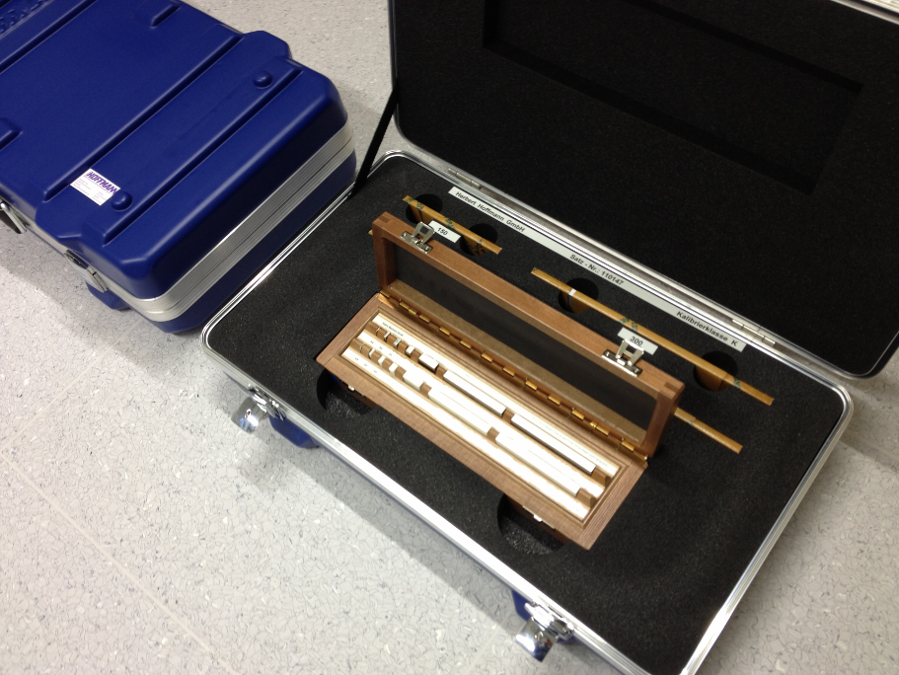
Figure 1 – Transporting cases
Once the measurements have been completed, the package shall be sent to the following participant. The steel gauge blocks need to be protected against corrosion when not being measured by means of protective oil. Please cover them with this product before packing them for transportation or when stocked for more than three days.
Each participating laboratory shall cover the costs of shipping and transport insurance against loss or damage. The package should be shipped with a reliable parcel service of its choice. Once the measurements have been completed, please inform the pilot laboratory and the following participant when the package leaves your installations indicating all pertinent information. If, at any point during circulation, the package is damaged, it shall be repaired by the laboratory before shipping it again. In the case that a laboratory or its shipping agent damages one or more artefacts, they may be required by the pilot to replace the artefacts at their own cost (or from the insurance).
For shipment outside the EU the package is accompanied by an ATA carnet. Outside EU the carnet shall always be shipped with the package, never inside the box, but apart. Please be certain, that when receiving the package, you also receive the carnet! For shipment inside the EU the ATA carnet may be shipped inside the box.

Artefacts

Description of artefacts
The package contains 10 gauge blocks. The gauge blocks are of rectangular cross section and comply with the calibration grade K of the standard ISO 3650. Note: the gauge blocks were selected for good quality of the faces and small variation in length, the limit deviation t_{e} from nominal length may not be met by some of the artefacts.
The coefficients of thermal expansion given in the following table are obtained by the manufactures and should be used as such. Following a decision by the WGDM a pre-determination of this important artefact parameter is not to be communicated to the participants.
Table 3. List of artefacts.
Identification | Nominal length  /mm | Expansion coefficient  /10⁻⁶ K⁻¹ | Manufacturer
2’10282 | 0.5 | 11.52 ± 0.5 | CARY
3’23288 | 1.01 | 11.52 ± 0.5 | CARY
21’23584 | 1.1 | 11.52 ± 0.5 | CARY
1’0071 | 6 | 11.52 ± 0.5 | CARY
16’0087 | 7 | 11.52 ± 0.5 | CARY
7’0103 | 8 | 11.52 ± 0.5 | CARY
18’23395 | 15 | 11.52 ± 0.5 | CARY
24’23259 | 80 | 11.52 ± 0.5 | CARY
7’23260 | 90 | 11.52 ± 0.5 | CARY
29’23539 | 100 | 11.52 ± 0.5 | CARY

Measuring instructions

Handling the artefact
The gauge blocks should only be handled by authorized persons and stored in such a way as to prevent damage. Before making the measurements, the gauge blocks need to be checked to verify that their measuring surfaces are not damaged and do not present severe scratches and/or rust that may affect the measurement result. The condition of the blocks before measurement should be registered in the form provided in appendix B. Laboratories should attempt to measure all gauge blocks unless doing so would damage their equipment. If a gauge block will not wring readily, the participant shall inform the pilot about this problem, stating the respective gauge block and face. No participant shall try to re-finish measuring faces by burring, lapping, stoning, or whatsoever. The measurement of the face concerned or the complete gauge block shall be omitted.
Measurements may only be performed using equipment normally used to offer the relevant CMC service. In case of multiple CMC services in this area, only the service/equipment with the smallest uncertainty should be used, unless the pilot and other participants agree to allow additional instruments to be used; in which case, only the results of the instrument/service with the smallest uncertainty may contribute to the KCRV. No other measurements are to be attempted by the participants and the gauge blocks should not be used for any purpose other than described in this document. The gauge blocks may not be given to any party other than the participants in the comparison.
The gauge blocks should be examined before despatch and any change in condition during the measurement at each laboratory should be communicated to the pilot laboratory. After the measurements, the gauge blocks must be cleaned and greased. Ensure that the content of the package is complete before shipment. Always use the original packaging.

Traceability
Length measurements should be traceable to the latest realisation of the metre as set out in the current “Mise en Pratique”. Temperature measurements should be made using the International Temperature Scale of 1990 (ITS-90).

Measurands
The gauge blocks shall be measured based on the standard procedure that the laboratory regularly uses for this calibration service for its customers. The “A” surface is the marked measuring face for gauge blocks with nominal length < 6 mm and the right hand measuring face for gauge blocks with a nominal length ≥ 6 mm, respectively (see Figure 2).
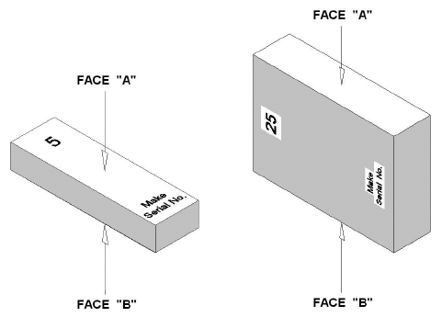
Figure 2 – Nomenclature of faces
The measurand to be reported is the deviation e_{c} of the central length l_{c} from the nominal length l_{n} of a gauge block. In this project the arithmetic mean of the two values for wringing on both faces is considered as representative for e_{c} (see equation (1), the superscripts label the face wrung to the platen). In cases where only one face could be wrung the corresponding value should be reported as the result.
with and (1)
As an optional auxiliary measurand the difference of the found deviations d_{c} when the block is wrung to face A and face B, respectively, should be reported according to equation (2). Care has to be taken to use the correct sign.
. (2)

Measurement uncertainty
The uncertainty of measurement shall be estimated according to the ISO Guide to the Expression of Uncertainty in Measurement. The participating laboratories are encouraged to use their usual model for the uncertainty calculation.
All measurement uncertainties shall be stated as standard uncertainties. The corresponding effective degree of freedom should be stated by the participants. If none is given, ∞ is assumed. For efficient evaluation and subsequent assessment of CMC claims an uncertainty statement in the functional form (3) is preferred:

standard uncertainty with ν_{eff} = ?? (3)
Additionally, in the report of the measurement technique (Appendix D) the participant should list any relevant CMC claims for the service(s) related to the comparison.

Optical phase change and roughness correction
The position of the plane where light is reflected on a surface is depending mainly on the material and surface finish. As the free measuring face of the gauge block under measurement and the platen where it is wrung are in general different in both characteristics, this difference varies and a correction has to be applied. It shall be estimated or determined by each laboratory according to its calibration procedure as it usually does it for its customers.
Methods usually applied to determine this correction are the stack method, the total integrating sphere technique, the coupled interferometer method, etc. Participants should state their technique in appendix D.

Reference condition
Measurement results should be reported for the reference conditions as set down in the standard ISO 3650. Specifically the reference temperature of 20 °C, standard pressure of 101 325 Pa and the orientation are of importance. For corrections the linear thermal expansion coefficient provided in this document (table 3) should be used.

Reporting of results

Results and standard uncertainties as reported by participants
As soon as possible after measurements have been completed, the results should be communicated to the pilot laboratory within six weeks at the latest.
The measurement report forms in appendix C of this document will be sent by e-mail (Word document) to all participating laboratories. It would be appreciated if the report forms (in particular the results sheet) could be completed by computer and sent back electronically to the pilot. In any case, the signed report must also be sent in paper form by mail or electronically as a scanned pdf document. In case of any differences, the signed forms are considered to be the definitive version.

When reporting the results of the comparison, each participant should also report the identifier, range and uncertainty of any existing CMC related to the comparison. This will be used by the pilot when checking whether or not CMC claims are supported by the comparison results.
In the case that the measurement uncertainty reported by a participant in a comparison is significantly higher than the relevant CMC claim, this should be explained at the time of submitting the results (e.g. air conditioning failure at time of measurements, damage on artefacts affecting measurements).
Following receipt of all measurement reports from the participating laboratories, the pilot laboratory will analyse the results and prepare within 1 month a first draft A.1 report on the comparison. This will be circulated to the participants for comments, additions and corrections.

Analysis of results

Calculation of the KCRV
The key comparison reference value (KCRV) is calculated on a gauge-per-gauge basis as the weighted mean of the participant results. The check for consistency of the comparison results with their associated uncertainties will be made based on Birge ratio, the degrees of equivalence for each laboratory and each gauge block with respect to the KCRV will be evaluated using E_{n} values, along the lines of the WG-MRA-KC-report-template. If necessary, artefact instability, correlations between institutes, and the necessity for linking to another comparison will be taken into account.

Artefact instability
Steel gauge blocks occasionally show a growing or a shrinkage the rate of which is approximately linear with time. Since the artefacts used here are of unknown history, the instability of the blocks must be determined in course of the comparison. For this check the measurements of the pilot laboratory are used exclusively, not that of the other participants. Using these data a linear regression line is fitted and the slope together with its uncertainty is determined (per gauge block).
Three cases can be foreseen:
- The linear regression line is an acceptable drift model and the absolute drift is smaller than its uncertainty. The gauge block is considered stable and no modification to the standard evaluation procedure will be applied. In fact the results of the pilot’s stability measurements will not influence the numerical results in any way.
- The linear regression line is an acceptable drift model and the absolute drift is larger than its uncertainty, i.e. there is a significant drift for the gauge block. In this case an analysis similar to [Nien F Z et al. 2004, Statistical analysis of key comparisons with linear trends, Metrologia 41, 231] will be followed. The pilot influences the KCRV by the slope of the drift only, not by the measured absolute lengths.
- The data are not compatible at all with a linear drift, regarding the uncertainties of the pilot’s measurements. In this case the artefact is unpredictably unstable or the pilot has problems with its measurements. TC-L has to determine the further approach.

Correlation between laboratories
Since the topic of this project is the comparisons of primary measurements, correlations between the results of different NMIs are unlikely. A possible exception is the common use of the recommended thermal expansion coefficients (from table 3). A correlation will become relevant only when the gauge blocks are calibrated far away from 20 °C which should not be the case. Thus correlations are normally not considered in the analysis of this comparison. However if a significant drift exist, correlations between institutes are introduced by the analysis proposed in section 7.2.

Linking of result to other comparisons
The CCL task group on linking CCL TG-L will set guidelines for linking this comparison to any other eky comparison within CCL for the same measurement quantity.

Appendix A – Reception of Standards
To: | Pilot name, pilot institute  Pilot address  Fax: xxx e-mail: xxx@yy
From: | NMI: ……………………………… Name: ………………………………  Signature: ……………………………… Date: ………………………………

We confirm having received the gauge blocks for the CCL-K1 comparison on the date given above.
After a visual inspection:
There are no apparent damages; their precise state will be reported in the form provided in Annex B/C once inspected in the laboratory along with the measurement results.

We have detected severe damages putting the measurement results at risk. Please indicate the damages, specifying every detail and, if possible, include photos. If it is necessary use additional sheets to report it.

Appendix B – Conditions of Measuring Faces
To: | Pilot name, pilot institute  Pilot address  Fax: xxx e-mail: xxx@yy
From: | NMI: ……………………………… Name: ………………………………  Signature: ……………………………… Date: ………………………………

After detailed inspection of the measuring faces of the gauge blocks these are the results. Please mark significant surface faults (scratches, indentations, corrosion, etc.).
Short gauge blocks – steel
Short gauge blocks – steel | face |  | A |  | B |  | A |  | B |  | A |  | B |  | A |  | B
Short gauge blocks – steel | l_{n} |  | 0,5 mm |  |  |  | 1,15 mm |  |  |  | 3 mm |  |  |  | 5 mm
Short gauge blocks – steel | face |  | A |  | B |  | A |  | B |  | A |  | B
Short gauge blocks – steel | l_{n} |  | 7 mm |  |  |  | 23,5 mm |  |  |  | 80 mm |  |  |  | 100 mm

Appendix C – Results Report Form
To: | Pilot name, pilot institute  Pilot address  Fax: xxx e-mail: xxx@yy
From: | NMI: ……………………………… Name: ………………………………  Signature: ……………………………… Date: ………………………………

Short gauge blocks, steel
l_{n} / mm | Ident. number | e_{c} / nm | u(e_{c}) / nm | ν_{eff} | d_{c} / nm | u(d_{c}) / nm | ν_{eff}
0,5
1,15
3
5
7
23,5
80
100

Functional form of standard uncertainty
standard uncertainty with ν_{eff} = ??
Gauge block set | a / nm | b / 1 | Comment
Short, steel

Appendix D – Description of the measurement instrument
To: | Pilot name, pilot institute  Pilot address  Fax: xxx e-mail: xxx@yy
From: | NMI: ……………………………… Name: ………………………………  Signature: ……………………………… Date: ………………………………
Make and type of instrument(s)

Light sources / wavelengths used or traceability path:

Description of measuring technique (including any corrections such as phase correction & platen material, vertical to horizontal corrections etc):

Range of gauge block temperature during measurements & description of temperature measurement method:

Relevant 95 % CMC uncertainty claim for the service(s) related to this comparison topic (if existing) and identifier of the CMC

If the reported uncertainty is significantly higher than that of the related CMC, explanation for the increased uncertainty

(use additional pages as needed)

