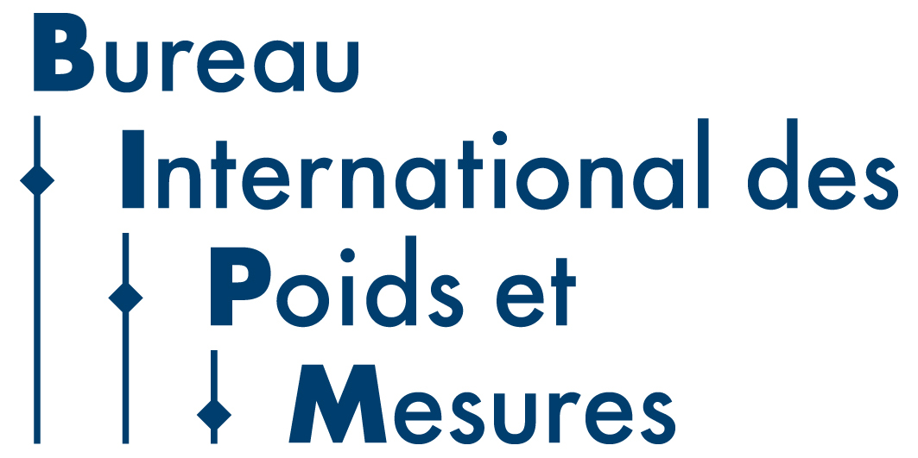

Draft Agenda for the 30th meeting of CCQM – 10-11 April 2025

Venue: Pavillon du Mail, BIPM, Sèvres, France.

Hybrid meeting with on site and online participation

Day 1: Thursday 10 April 2025
CCQM Plenary Session
Chair: Sang-Ryoul Park

Session 1: Opening Session
09.00-09.20 1. Opening of the meeting, welcome and introductions
2. Appointment of a Rapporteur and approval of the agenda
09.20-09.40 3. Opening remarks of the CCQM President and actions from the 29th meeting of the CCQM
09.40-09.50 4. Plans for the 150 year anniversary of the Metre Convention (M.Milton)

Session 2: Stakeholder Engagement and Sector Focus
5. Reports from CCQM Task Groups including outcomes of workshops
09.50-10.10 5.1 CCQM Task Group on Food Metrology: Progress Report (J. Melanson)
10.10-10.30 5.2 CCQM Nano- and Microplastics Measurements and Standards Task Group: Report and workshop outcomes (A. Jamting)

10.30-11.00 Coffee Break

11.00-11.15 5.3 CCQM Task Group on Metrology for Pandemic Preparedness: Progress Report (J. Braybrook
11.15-11.30 5.4 CCQM Task Group on Metrology for Li-ion Batteries: Progress Report (S. Seitz)
11.30-11.40 5.5 Activities of the CCQM Task Group for gene delivery systems. (J. Braybrook)
11.40-11.50 5.6 Progress on a potential task group on biosensors (S. Seitz)
11.50-12.00 5.7 Discussion on Task Group activities

6. CCQM Workshops and Sector Engagement
12.00-12.15 6.1 Update from the CIPM STG on Climate and Environment (R. Wielgosz)
12.15-12.30 6.2 CCQM Workshop on Digital and FAIR Chemical and Biological Reference Data
and Certificates and proposal for a CCQM Digitalization Task Group (C. Gonzalez)
12.30-12.45 6.4 CCQM Workshop on Protein Structure and Activity (M. Ryadnov)
12.45-13.00 6.5 Report from the JCTLM (M. Panteghini)

13.00-14.00 Lunch

14.00-14.20 6.6 Report from the IFCC (C. Cobbaert)
14.20-14.30 6.7 Discussion on CCQM activities in support of Laboratory Medicine

Session 3: CCQM Strategy, Reports and Committee Activities
7. CCQM Strategy
14.30-14.45 7.1 Progress with update on the CCQM 2021-2030+ strategy (R. Wielgosz)
14.45-14.30 7.2 Discussion on CCQM Strategy updates

8. Reports from the CCQM Working groups
15.00-15.30 8.1 Organic Analysis (M. Fernades-Whaley)

15.30-16.00 Coffee Break

16.00-16.30 8.2 Inorganic Analysis (M. Winchester)
16.30-17.00 8.3 Gas Analysis (P. Brewer)
17.00-17.30 8.4 Isotope Ratio (Z. Mester)
17.30-18.00 8.5 Surface Analysis (A. Shard)

18.00-19.00 Reception at BIPM

Day 2: Friday 11 April 2025

09.00-09.30 8.6 Protein Analysis (C. Swart)
09.30-10.00 8.7 Cell Analysis (J. Braybrook)
10.00-10.30 8.8 Nucleic Acid Analysis (J. Huggett)

10.30-11.00 Coffee Break

11.00-11.30 8.9 Electrochemical Analysis and Classical Methods (S. Seitz)
11.30-12.00 8.10 Key Comparison and CMC Quality (A. Botha)
12.00-12.30 8.11 BIPM Headquarters Program on Metrology in Chemistry (R. Wielgosz)
12.30-12.40 8.12 CCQM Task Group on KCRV estimation (S. Ellison)
12.40-12.50 8.13 ad hoc WG on the mole (R. Brown)
12:50-13:00 8.14 Approval of proposals for CCQM Comparisons

13.00-14.00 Lunch
14.00-14.30 9. CC Governance and Operational Issues
9.1 Questions on ‘Overlapping broad and specific CMCs’
9.2 Issues with transport of comparison samples (C. Swart)
9.3 Future process for rereview of CMCs and CMCs not supported by comparisons (A.Botha)

14.30-15.00 10. Reports from RMOs (AFRIMETS, APMP, COOMET, EURAMET, GULFMET, SIM)

15.00-15.30 11. Discussion and questions on written reports from International Organizations in liaison with the CCQM (International Atomic Energy Agency [IAEA], European Commission Joint Research Centre [JRC], International Union of Pure and Applied Chemistry [IUPAC], ISO TC/334- Reference Materials, Cooperation on International Traceability in Analytical Chemistry [CITAC], International Federation of Clinical Chemistry and Laboratory Medicine [IFCC]

15.30-15.50 12. CCQM Meetings
12.1 CCQM WG meetings to be held in 2025
12.2 Dates CCQM meetings in 2026 and 2027

15.50-16.00 13. Closing remarks from the CCQM President
16.00 Close

