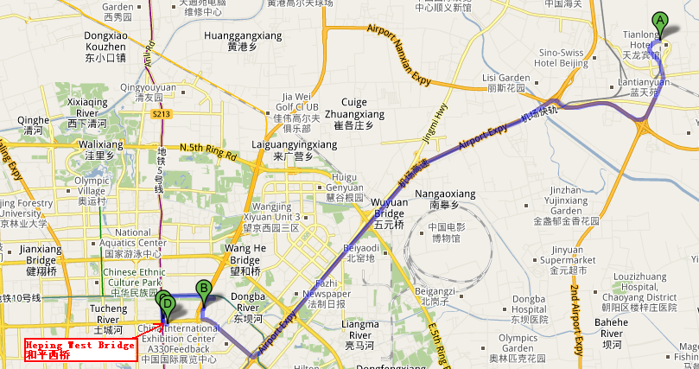
Figure 1
In figure 1,
A= Terminal 3 of Beijing Capital International Airport
B= Crowne Plaza Sun Palace (Yunnan Dasha)
C= Guizhou Mansion
D= National Institute of Metrology(NIM)
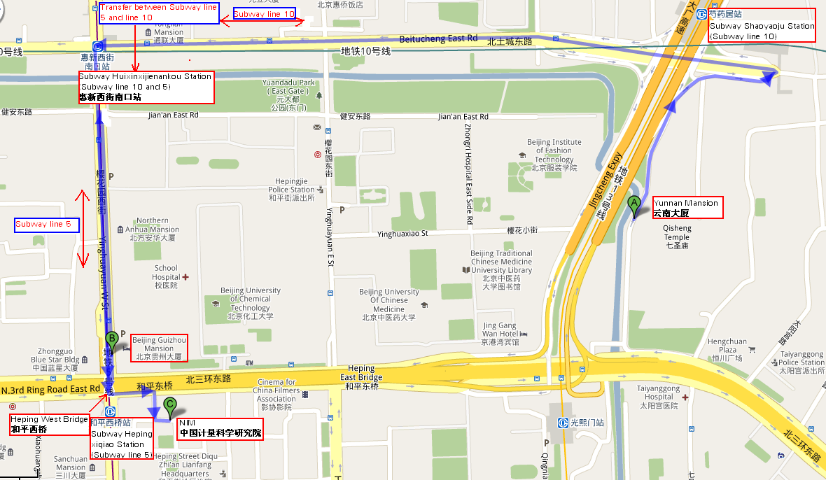
Figure 2
In figure 2,
A= Crowne Plaza Sun Palace (Yunnan Dasha)
B= Guizhou Mansion
C= National Institute of Metrology(NIM)

Note: To take a taxi from the airport to both hotel, the charge will be around ￥80 RMB.

