CONTRIBUTION TO THE CCL/CCTF
2004

A.Clairon

BNM-SYRTE
61 Avenue de l’Observatoire, 75014 PARIS, FRANCE

Measurement of the ⁸⁷Rb hyperfine splitting by using atomic fountains.

The BNM-SYRTE operates three laser cooled atomic fountains, the first one FO1 is in operation since 1994, and the second one FOM has been derived from the space clock prototype. The third one, FO2, the Rb Cs dual fountain is an improved version of the Rb clock described in [1]. A schematic view of this apparatus is shown in fig.1. This clock is described in detail in [2]. These fountains have been continuously upgraded and their accuracy reached 8. 10⁻¹⁶ for Cs and 6. 10⁻¹⁶ for ⁸⁷Rb in 2003. One motivation for the construction of the ⁸⁷Rb fountain is its low collisional frequency shift. Recent measurements foresee a shift at least 70 times lower than for Cs [3] [4].

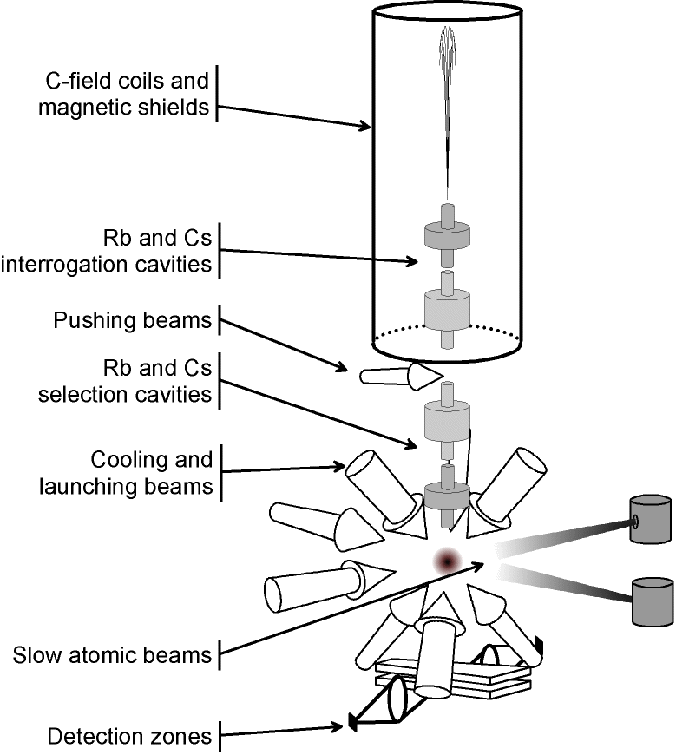

Fig 1: FO2 experimental setup. Laser slowed atomic beams are used to load pure optical molasses. Five mu- metal shields surround the interaction region. The clock is operated alternatively with Rb or Cs. Atoms are selected in the mF =0 level by microwave and light pulses. The microwave cavities are symmetrically fed and have a Q factor of 7000. The atom temperature is 1K.
For instance, a rubidium clock can be operated with a quantum limited frequency stability of 4*10^{-14-1/2} ( When 10⁶ atoms are detected per fountain cycle) with a collisional frequency shift as low as 2*10⁻¹⁶. When the interrogation cavity is detuned by 100 kHz from the atomic resonance the frequency shift due to the cavity pulling effect is also 10⁻¹⁶ [5]. The accuracy evaluation procedures of Cs and Rb fountains are similar. The main difference concerns the measurement of the collisional frequency shift: For Cs we continuously alternate series of measurements at low and high density to extrapolate to zero density. When using a standard method to vary the atomic density the accuracy of the determination of the collisional shift is 10-20% of its value. When using a new method based on a transfer of population by adiabatic passage one can prepare cold atomic samples with a well-defined ratio of density and atom number [6]. This method is accurate to 1% of the collisional shift. For Rb, we operate the clock at low density such that Δν_{coll} ≤10⁻¹⁶.
EFFECT | Shift  [10-¹⁵] | Uncertainty  [10-¹⁵] | Evaluation Method
Second order Zeeman  (a) | 320.7 | .47 | Magnetic field map by using the microwave mF=1mF=1 transition
Blackbody radiation shift  (b) | -12.7 | .21 | The temperature of the interaction region is monitored with five platinium thermistors. The resonance frequency of the microwave cavity is also used to monitor the temperature
Cold collisions and cavity pulling  (c) | 0 | .1 | Density evaluation and variation of the atom number. The cavity was tuned to ±20kHz from atomic resonance.
Residual Doppler Effect  (d) | 0 | .2 | Calculations using a 3D modelization of the microwave field in the cavity.
Recoil effect  (e) | 0 | ≤ .1 | Calculations
Pulling by neighboring transitions |  | ≤ .1 | Calculations
Synchronous perturbations and spectral impurities  (f) |  | ≤ .1 | Fountain timing variation. Operation using π/2 and 3π/2 pulses.
Microwave leakage |  | ≤ .1 | Measurements using π/2 and 3π/2 pulses. New design of the microwave generator.
Red Shift | 6.5 | .1
Total 1σ  (quadratic sum) (g) |  | .6
Table 1: Uncertainty Budget of the FO2 ⁸⁷Rb Clock during the 2002 frequency measurement.

(a): The quoted uncertainty corresponds to a .1nT magnetic field fluctuation. The average magnetic field is 200nT and its homogeneity is better than .3nT. Both Rb and Cs atoms are used to map the magnetic field. Recently, the magnetic field stability has been improved and reaches now10⁻¹²T over one day.

(b): The blackbody radiation near room temperature shifts the hyperfine frequency by:
= K_{87Rb}(T/300)⁴ where K_{87Rb} = -8.6 (.086) 10⁻⁵ Hz is deduced from [1], T is the absolute temperature of the blackbody radiation. The quoted uncertainty corresponds to a 1K uncertainty on the temperature and to1 % uncertainty on the K_{87Rb} coefficient.

(c): During the 2002 measurements the rubidium density was less than 5*10⁶ atoms /cm³ . The collisional frequency shift is then ≤5*10⁻¹⁷. The cavity pulling was less than 210⁻¹⁷.

(d): Our fountain design allows us to operate the clock with a symmetrically fed or asymmetrically fed cavity. Recent experiments performed with FO2, when using cesium, reveal a frequency shift of 8*10⁻¹⁶ ±3*10⁻¹⁶ between these two situations. The sign of this frequency shift depends on the feed side; this is a clear indication of phase gradients, larger than expected, in the microwave cavity. When the cavity is symmetrically fed the shift is ≤±310⁻¹⁶.

(e): Recent calculations by P. Wolf et al foresee a shift ≤310⁻¹⁷ [7]. Furthermore the recoil frequency shift is almost the same for Cs and Rb.

(f): Changing the microwave power change the sensitivity of the clock to a time dependent perturbation of the phase of the interrogation signal. [8]

(g): The uncertainty budget of Cs fountains involved in the 2002 measurement is similar to the ⁸⁷Rb budget. The main difference is the collisional frequency shift which is .5*10⁻¹⁵. The total inaccuracy budget is 810⁻¹⁶ for Cs fountains.

During the past 6 years we have performed 4 measurements of the hyperfine frequency of ⁸⁷Rb [9]. A new measurement is under way. For the three last measurements two Cs fountains where used. The average frequency of the two Cs fountains is used to determine the Rb frequency. Each measurement last 1-2 months during which an accuracy evaluation of each fountain is performed. In measurements reported here the frequency instability is (1-2)*10^{-13-1/2}. In fig.2 are plotted all our Rb-Cs frequency comparisons. The most accurate measurement was performed in 2002. The result is:

ν ( ⁸⁷Rb)= 6 834 682 610. 904 324 (4)(7) Hz

The first number in brackets is the statistical uncertainty (Type A) deduced from the Allan standard deviation of the clocks. The second number represents the combined type B uncertainties of the fountains. The total uncertainty is 1.2*10⁻¹⁵. As shown in fig.2 no drift is detected over a five years period.

Fig2: Measured 87Rb frequencies over 5 years. The 1999 value is conventionally used as a reference, ν(1999) = 6834682610.904333 Hz.

Future Improvements: The frequency stability of FO2 has been considerably improved by using microwave synthesizer based on a cryogenic oscillator. The stability is now better than 2*10^{-14-1/2} when using Cs , similar results are anticipated, after some improvements of the cold atom source, when using Rb. The new method to evaluate the collisional shift using adiabatic passage has been recently improved and reaches now .3% accuracy in the determination of the shift. The magnetic stability has been significantly improved so that its contribution to the accuracy budget will be less than 10⁻¹⁶. In 2004 we should have FO2 working simultaneously with Rb And Cs. The fountain FO1 has been refurbished and should exhibit accuracy and frequency stability similar to the ones obtained with FO2.

References:
[1]: High-accuracy measurement of the 87Rb ground-state hyperfine splitting in an atomic fountain. S. Bize, Y. Sortais, M.S. Santos, C. Mandache, A. Clairon, C. salomon. Europhys,lett.,45 (5) pp.558-564 (1999)
[2]: Cs and Rb Foutains : recent results.S. Bize et al. 6th symposium on frequency standards and metrology. 2001. World Scientific; pp.53-63
[3]: Cold Collision Frequency Shifts in a ⁸⁷ Rb Atomic fountain. Y. Sortais et al. Phys.Rev. Lett., 85, 3117 (2000).
[4]: Laser cooled ⁸⁷ Rb clock. C. Fertig and K. Gibble. IEEE. Trans. Instrum. Meas., 48 :520-523,1999 and C. Fertig and K. Gibble, Phys. Rev. Lett., 85, 1622 (2000).
[5]: Cavity Frequency Pulling in Cold Atom Foutains. S;Bize,Y. Sortais,C. Mandache, A. Clairon and C. Salomon. I.EEE. Trans. IM 50, 503, 2001.
[6]: Controlling theCold Collision Shift in High Precision Atomic Interferometry. F. Pereira Dos Santos et.al. Phys.Rev. Lett., 89, 233004-1 (2002).
[7]: P; Wolf et al. 6th symposium on frequency standards and metrology. 2001. World Scientific; pp.593-596.
[8]: P. Lemonde et al. Proc. Of Frequency Control Symposium, P. 110 (1998).
[9]: Search for variations of fundamental Constants using Atomic Fountain Clocks. H. Marion et al. . Phys.Rev. Lett., 90, 150801-1 (2003).

