Optical Frequency Standards at the Physikalisch-Technische Bundesanstalt

Report to the Joint Working Group of the CCL/CCTF March 2004

PTB investigates and operates two different optical frequency standards. One is based on a single ¹⁷¹Yb⁺ ion confined and cooled in a radio-frequency trap. The second one employs a cloud of cold ⁴⁰Ca atoms in free flight after being cooled and trapped in a magneto-optical trap.

Single-ion optical frequency standard with ¹⁷¹Yb⁺

In the work on the single-ion optical frequency standard with ¹⁷¹Yb⁺ progress was made towards higher stability and towards an evaluation of systematic frequency shifts. Improvements in the laser frequency stabilization have allowed to observe the electric-quadrupole transition from the ²S_{1/2} ground state to the metastable ²D_{3/2} level (wavelength 436 nm, transition frequency 688 THz) with a Fourier-limited linewidth of 10 Hz (natural linewidth: 3.1 Hz) and with a resonant excitation probability in the range of 50 %. In order to investigate systematic frequency shifts at the Hertz level and below, a second ion trap was built and optical frequency comparisons have been performed [1,2]. The scheme of the experiment is shown in Fig. 1. Both traps use the same cooling laser setup and synchronous timing schemes for cooling, state preparation, and state detection. Using two independent digital servo systems, the error signals resulting from the probing of the atomic resonance signals are averaged over typically 10-20 measurement cycles before the detunings between the probe laser frequency and the probe light beams incident on the traps are corrected. In order to minimise servo errors due to the drift of the probe laser frequency, a second-order integrating servo algorithm is used. The servo time constants are in the range of 10-30 s. The differences of the detunings imparted on the probe beams are averaged over time intervals of 1 s and recorded.
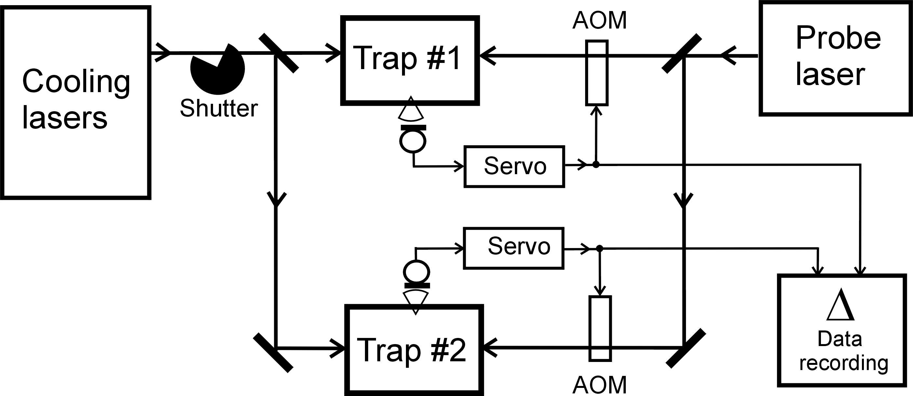

Fig. 1. Experimental setup for comparison of two ¹⁷¹Yb⁺ frequency standards. AOM: acousto-optic modulators, providing independent frequency shifts between the probe laser and the two ion traps.

Fig 2 shows a frequency comparison over a period of more than 2 hours [2]. At that time, the atomic resonance signal was resolved with nearly Fourier-limited linewidths of approximately 30 Hz in both traps. The mean frequency difference of the data shown in Fig. 2 is <Δ> ≈ 0.2 Hz, corresponding to a relative optical frequency offset of 3⋅10⁻¹⁶. Since <Δ> is smaller than the Allan deviation for long averaging times (σ_{y}(τ) ≈ 1⋅10⁻¹⁵ for τ ≥ 800 s), the observed offset is not statistically significant and consistent with our previous conservative estimate of 3 Hz for the confinement-related systematic shifts [3]. The latter are dominated by the quadrupole shift due to the interaction of the ²D_{3/2}(F=2, m_{F}=0) level with electric stray field gradients. A frequency difference of approximately 15 Hz was observed when a field gradient of 10 V/mm² was generated in one trap by superimposing a constant (dc) voltage on the radiofrequency trap field. A preliminary value for the quadrupole moment of the ²D_{3/2} state of (3.9±1.9)ea₀² can be derived from this measurement [1].

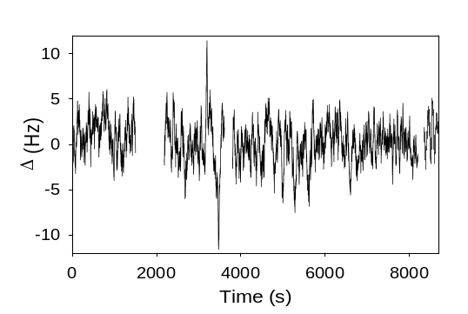

Fig. 2: Temporal variation of the frequency difference between two probe light fields independently frequency stabilised on the 436 nm reference transitions of two trapped ¹⁷¹Yb⁺ ions. The average frequency difference calculated from this data set is 0.2 Hz. The intervals without data points correspond to times when no frequency correction signal was produced by one of the trapped ions.

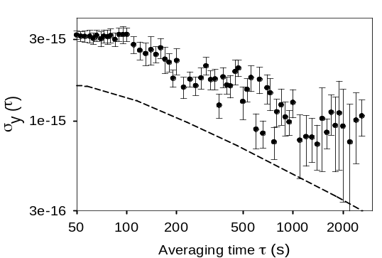

Fig. 3: Allan standard deviation of the data set shown in Fig. 2, normalized to the optical frequency of 688 THz. The dashed line shows the result of a Monte Carlo simulation of the servo action for the case that the fluctuations of the atomic resonance signals are determined by quantum projection noise.

As shown in Fig. 3, the variation of the Allan deviation with the averaging time τ is in qualitative agreement with a numerical calculation which simulates the effect of quantum projection noise for the realized experimental conditions. The observed Allan deviation however exceeds the quantum projection noise limit by approximately a factor of two. Temporal fluctuations of the probe laser emission spectrum which can lead to fluctuating servo errors are a possible reason for this excess instability. More recently, with a linewidth of the atomic resonance of 10 Hz an instability σ_{y}(500 s) ≈ 5⋅10⁻¹⁶ has been achieved for the difference frequency.
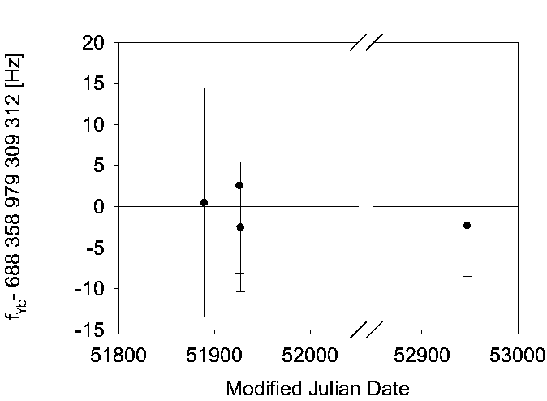
Fig. 4: Results of absolute frequency measurements of the ¹⁷¹Yb⁺ optical frequency standard.

The absolute optical transition frequency of ¹⁷¹Yb⁺ at 688 THz was measured against the caesium fountain clock CSF1 with the help of a femtosecond laser frequency comb generator. A first series of measurements in December 2000 and January 2001 gave the result
688 358 979 309 312 Hz with a total 1σ measurement uncertainty of 6 Hz [3]. In November 2003, the frequency was remeasured under the conditions of the reduced probe laser linewidth and with a new femtosecond laser system. The frequency value obtained in this measurement has the same total uncertainty like the average of the previous measurements and is insignificantly lower by 2 Hz (see Fig. 4). The results and uncertainty contributions for these measurements are summarized in Table 1.
Combined with recently published values for the constancy of other transition frequencies in Hg⁺ and H this measurement provides a limit on the present value for a possible temporal variability of Sommerfeld’s fine structure constant α at the level of 2⋅10⁻¹⁵ per year.

Table 1: Optical frequency measurement of the 688 THz (435.5 nm) ²S_{1/2}(F=0) - ²D_{3/2}(F=2)
transition of a single trapped ¹⁷¹Yb⁺ ion

Uncertainty contributions due to systematic shifts of the measured Yb⁺ transition frequency; February 2004

Weighted mean of the 2000/2001/2004 measurements:
f_{Yb} = 688 358 979 309 311 Hz (transition frequency at 298 K ambient temperature)

Systematic shift effect; conditions | Uncertainty contribution  (estimated standard uncertainty)
quadratic Zeeman effect  (magnetic field 1.2 μT ± 0.2 μT) | 0.01 Hz
quadratic Stark effect, trap field  (3-d micromotion compensation, Doppler cooling limit) | 0.01 Hz
quadratic Stark effect, stray light and thermal radiation  (deviations from ambient 298 K blackbody spectrum) | 0.1 Hz
relativistic Doppler shift  (3-d micromotion compensation, Doppler cooling limit) | 0.01 Hz
quadrupole shift  (maximum electric stray field gradient at trap center  compatible with secular motion spectrum observations) | 3 Hz
incorrect determination of line center  (FWHM 10 Hz, drift compensation < 0.03 Hz/s) | 0.5 Hz
Combined systematic uncertainty | 3.1 Hz

Calcium optical frequency standard

An optical frequency standard based on cold and ultra-cold neutral Ca atoms is operated at PTB where the intercombination transition (λ= 657 nm) from the ¹S₀ ground state to the ³P₁ state is interrogated. Its frequency has been measured with respect to the Cs hyperfine transition over eight years. Progress has been made along the following directions:
- The linewidth of the diode laser used for interrogation has been reduced to about 1 Hz as could be derived from a beat note between two independent laser systems each stabilised by a Pound-Drever-Hall technique to a non-tuneable high-finesse Fabry-Perot resonator made of ultra-low expansion glass (ULE).
- It has been shown that with cold atoms in the millikelvin range given by the Doppler limit of the cooling transition at 423 nm the influence of the residual first-order Doppler shift ultimately limits the accuracy of a Ca frequency standard. The shift results from phase variations experienced by atoms in a ballistically expanding and falling cloud which depends on the tilt angle of the laser beam, its curvature at the position of the atomic cloud and on the velocity of the atoms. A method has been developed to measure and to correct the associated spurious phase shifts and to reduce their influence [4,5] to about 2 ⋅ 10⁻¹⁴ [6].
- A quench cooling method has been developed where the intercombination transition can be used to cool the atoms into the microkelvin range [7]. From the investigations with these ultracold atoms it has been concluded that a fractional uncertainty of below 10⁻¹⁵ can be achieved [8]. The uncertainty however achieved so far is given in Table 2.
- The influence of collisions on the frequency of the intercombination transition was determined for temperatures of the cloud in the millikelvin and microkelvin regime (Figure 5).
Interactions between the atoms in the laser cooled ensemble, i. e. cold collisions, might lead to a frequency shift of the clock transition. In order to determine the density dependence of the frequency shift we have measured the frequency differences as a function of average density differences. The density ρ was varied by switching a repump laser at 672 nm which closed a leak to a metastable level and hence changed the number of trapped atoms while all other parameters like the magnetic field, loading time, frequency of the trapping light and laser beam profile were kept constant. We have checked that the radius and temperature of the trapped cloud did not change significantly when the average density was varied by a factor of five. At 3 mK the measurement of the collisional shift depending on the density (Fig. 5 a) gave Δν/ν= (3 ± 4.4) ⋅ 10⁻³⁰ m³ ρ. The corresponding frequency shift for a resolution of 1.2 kHz (T = 215 μs) would be (1.2 ±1.8) Hz. At 20 µK higher densities and higher resolution could be achieved. This leads to a reduced uncertainty for the collisional shift Δν/ν= (-0.4 ± 1.2) ⋅ 10⁻³¹ m³ ρ. The corresponding shift at the densities used in the frequency measurement is (-20 ± 55) mHz.
Within the uncertainty of this measurement no significant shift has been observed. From the uncertainty of this measurement we conclude that the collisional shift in calcium is about four orders of magnitude lower than in caesium.
The low density dependence allows one to use considerably higher densities and atom numbers compared to that in ultracold caesium ensembles used in Cs atomic clocks and temperatures of about 10 μK.
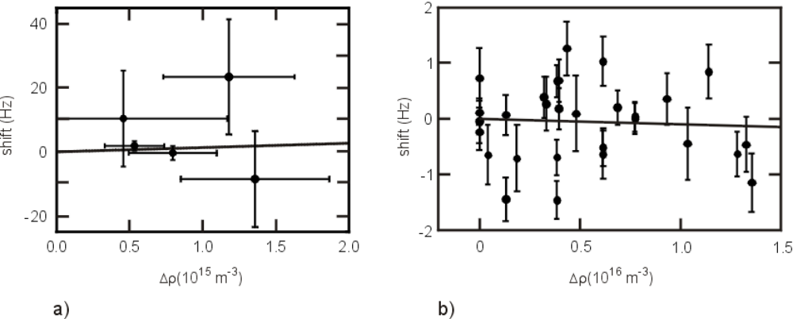
Fig. 5: Measurement of the density-dependent frequency shift (a) using cold atoms (T ~3 mK), (b) using ultra-cold atoms (T ~20 μK). The lines represent a linear regression to the data.
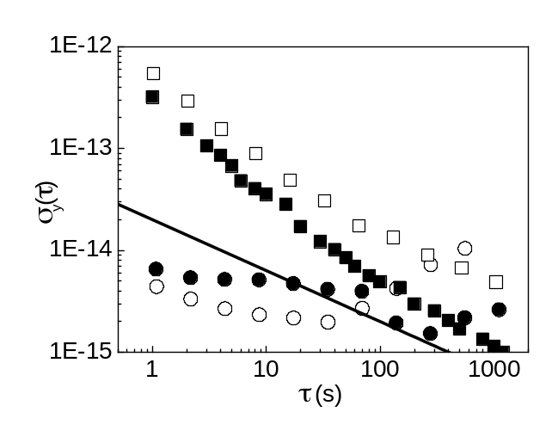
Fig.6: Allan standard deviation as a function of the averaging time τ. The line represents σ(τ) = 2 ⋅ 10⁻¹⁴ (τ/s)^{1/2}. as derived from the signal-to-noise ratio of the Ca stabilised laser. The open squares refer to the Allan standard deviation measured between the Ca standard and the hydrogen maser and the full squares represent the instability of the hydrogen maser. Open circles give the Allan standard deviation of two independent resonator-stabilised interrogation lasers and the full circles represent the stability of the calcium-locked laser with respect to a resonator-stabilised laser.

- With the present set-up of the PTB the fractional frequency instability expressed by the Allan standard deviation is σ (τ) = 2 ⋅ 10⁻¹⁴ (τ/s)^{1/2} as has been observed by measuring the Allan standard deviation between a Ca-stabilised laser and a laser stabilised to a Fabry-Perot cavity (Fig. 6).

- The frequency of the optical Ca standard of PTB has been measured for more than eight years where the measurements until the year 2000 were performed with a frequency chain and later with a femtosecond comb (Fig.7).
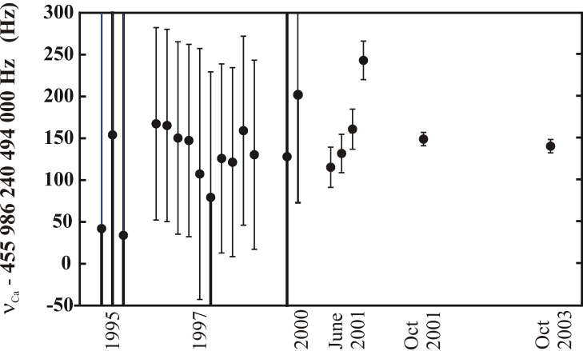

Fig.7: Results of absolute frequency measurements of the ⁴⁰Ca optical frequency standard.

The latest measurements in 2001 and 2003 have the smallest uncertainties and correspond to
the uncertainty budget of Table 2. The measurement of October 2003 with ultra-cold atoms led to a value of 455 986 240 494 143 Hz which is 7 Hz lower than the value obtained two years ago and the mean value of all previous measurements (excluding the latest one). Between the two measurements the set-up has been largely modified. The dye laser used for interrogation has been replaced by a diode laser system, frequency synthesizers have been replaced, the software and large portions of the hardware for the measurement control have been replaced, a new cooling laser system and a new frequency comb has been used. A new method of state-sensitive detection (423 nm) was used which replaced the detection of the excited state atoms by monitoring the intercombination transition (657 nm).
We attribute the main difference between both measurements to a correction of the chirp of the laser phase which was measured and corrected for the first time in the measurement in October 2003.
Table 2: Uncertainty of PTB’s optical Ca frequency standard

Effect | T = 3 mK  (8. Oct. 2001) | T = 12 µK  (8. Oct. 2003) | T = 12 µK  (achievable)
Residual first-order Doppler effect | 2.6 Hz | 1.0 Hz | 150 mHz
Second-order Doppler effect | 0.005 Hz | 0.02 mHz | 0.01 mHz
Other phase contributions | 4 Hz | 1.6 Hz | 200 mHz
Asymmetry of line shape | 0.05 Hz | 0.05 Hz | 50 mHz
Magnetic field (64 Hz/mT²) | 0.1 Hz | 0.2 Hz | 200 mHz
ac Stark effect | 0.1 Hz | 0.1 Hz | 100 mHz
Quadratic Stark effect (⏐E⏐ < 2 V/cm) | 0.02 Hz | 0.02 Hz | 20 mHz
Black body radiation
Oven | 4.3 | 3.9 Hz
Chamber (300 K) | 0.07 Hz | 0.07 Hz | 70 mHz
Collisions of cold atoms | 1.8 Hz | 0.06 Hz | 60 mHz
Influence of laser drift | 3.2 Hz | 0.1 Hz | 100 mHz
Sum in quadrature | 7.4 Hz | 4.4 Hz | 400 mHz
Statistical uncertainty of the frequency meas. | 3 Hz | 3 Hz | 100 mHz
Cs clock (1 ⋅ 10⁻¹⁵) | 0.5 Hz | 0.5 Hz | 500 mHz
Total uncertainty δν | 8 Hz | 5.4 Hz | 700 mHz
total relative uncertainty δν/ν | 2 ⋅ 10⁻¹⁴ | 1.2 ⋅ 10⁻¹⁴ | 1.6 ⋅ 10⁻¹⁵

References

[1] T. Schneider, Chr. Tamm, E. Peik, In: Proceedings of the 2003 IEEE Int. Frequency Control Symposium and the 17th European Frequency and Time Forum, Ed.: J. R. Vig, IEEE 2003

[2] Chr. Tamm, T. Schneider, and E. Peik, in: Laser Spectroscopy XVI, Eds.: P. Hannaford,
A. Sidorov, H. Bachor, and K. Baldwin (World Scientific, Singapore, 2004)
eprint physics/0402120

[3] J. Stenger, Chr. Tamm, N. Haverkamp, S. Weyers, and H. Telle, Opt. Lett. 26, 1589 (2001).

[4] G. Wilpers: Ein optisches Frequenznormal mit kalten und ultrakalten Atomen. PhD Thesis,
University of Hannover, Hannover (2002) and PTB-Bericht PTB-Opt-66 (ISBN 3-89701-892-6), Physikalisch-Technische Bundesanstalt, Braunschweig 2002.

[5] G. Wilpers, C. Degenhardt, T. Binnewies, A. Chernyshov, F. Riehle, J. Helmcke, U. Sterr, Appl. Phys. B 76, 149 (2002).

[6] J. Helmcke, G. Wilpers, T. Binnewies, C. Degenhardt, U. Sterr, H. Schnatz, F. Riehle:
IEEE Trans. Instrum. Meas. 52, 250 (2003).

[7] T. Binnewies, G. Wilpers, U. Sterr, F. Riehle, J. Helmcke, T. E. Mehlstäubler, E. M. Rasel, and W. Ertmer, Phys. Rev. Lett. 87, 123002 (2001).

[8] U. Sterr, T. Binnewies, C. Degenhardt, G. Wilpers, J. Helmcke, Fritz Riehle, J. Opt. Soc. Am. B 20, 985 (2003).

[9] G. Wilpers, T. Binnewies, C. Degenhardt, U. Sterr, J. Helmcke, F. Riehle, Phys. Rev. Lett. 89, 230801 (2002).

