25 March 2004

Informal status report of the NIST research toward optical frequency standards
to the
CCL/CCTF Joint Working Group.

The calcium optical frequency standard (456 THz, 657 nm)--

- We presently operate the Ca optical frequency standard almost exclusively using 2nd stage cooling and ultra-cold atoms (temperatures in the range of 1 to 10 microKelvin depending on conditions).
- An optical frequency comb that is stabilized to either the Ca standard or to the Hg+ single-ion standard allows direct comparison of the frequencies of the two optical standards as well as their absolute measurement via comparison to the frequency of a hydrogen maser, which is referenced to the Cs fountain clock. Recent measurements of the stability of the entire optical clock system (Ca, Hg+, the femtosecond comb and the two Doppler canceling links between the optical standards) has demonstrated excellent frequency stability, approximately 7 x 10⁻¹⁵τ^{-1/2} averaging down to about 3 x 10⁻¹⁶ at 1000 s.
- We are now evaluating the systematic frequency shifts and uncertainties in the Ca optical standard by using a combination of the following three methods:

  - A new interleaving detection method has been developed, wherein we alternate sequentially between normal operating conditions of the Ca standard and a state with one experimental parameter changed (e.g., the directions of the clock laser pulses, the laser cooling method and duration, state of the magnetic field, etc.). In most cases the interleaving between the operating states can be done fairly rapidly, at a rate of about 10 Hz. This approach allows detection of small phase-shifts in the optical Ramsey fringe pattern with a high update rate, and is proving useful as a diagnostic for systematic frequency shifts.
  - Absolute frequency measurements are made with an optical frequency comb that is locked to the Ca standard and whose repetition rate is measured by a counter referenced to a H-maser that is part of the NIST Time-Scale. The maser frequency is calibrated relative to the NIST primary fountain standard NIST-F1.
  - The optical comb is also used for frequency measurements of Ca relative to the Hg+ optical frequency standard.

By measuring the relevant experimental parameters of the Ca standard (atom velocity, magnetic fields, laser powers …) we can evaluate the system for possible systematic frequency shifts. This type of analysis indicates that all of the known frequency errors in the Ca standard should be very small – at the 1 Hz level or less. However, using both the interleaving method and by frequency comb comparisons relative to the Hg+ optical standard we are able to detect and measure frequency shifts of several Hz that depend on operating conditions of the
Ca standard. These shifts are reproducible, but not presently well understood. Several factors indicate possible uncontrolled time-dependent phase-shifts in AOMs and other possible electronic errors. Evaluations are ongoing, and they should provide some deeper understanding and solutions. The table below gives a brief summary of our previous frequency evaluation using milliKelvin Ca atoms, as well as projections for the expected performance that should be achievable using micro-Kelvin atoms. The question marks in the table indicate some of the potential frequency shifts that remain to be evaluated, and “--“ indicates shifts that are believed to be negligible.

 |  | Previous Ca frequency uncertainty using 2 mK atoms |  | Estimated performance  using 10 μK atoms
Perturbation | Sensitivity and comments | Typical Bias  (Hz) | Uncertainty (Hz) | Expected Bias  (Hz) | Estimated Uncertainty (Hz)
DC Stark Shift | -0.012 Hz/(V/cm)² | 0 | 0.1 |  | 0.01
Quadratic Zeeman | [61 Hz/mT²] | 23 | 1 | 2.4 | 0.002
Collision induced shifts | < 10⁻²⁴ρ(cm³) | 0 | 10 |  | ?
1st Order Doppler |  |  | 6 |  | .01
2nd Order Doppler |  | .002 | __ | __ | __
Wavefront curvature |  |  | 10.5 |  | 0.01
AC Stark shift due to clock laser |  | ? | 2 |  | 0.002
Blackbody Stark shift T= 300 K |  | 1 ? | 1 |  | 0.01
Uncontrolled Phase shifts in clock beams |  | 10 | 4 |  | ?
Electronic offsets |  | 0 | 12.5 | ? | .01
Lineshape asymmetry |  |  | 1 |  | ?
Total |  |  | 21 Hz |  | ?
The Hg+ optical frequency standard (1064 THz, 282 nm)—

- We continue to periodically measure the absolute frequency of the optical clock transition in Hg+. With our most recent measurements included (see figure below), the present value is ν_{Hg} = 1 064 721 609 899 143.5 (1.2) Hz, where the stated uncertainty is the statistical uncertainty only. The systematic uncertainty remains at ±10 Hz, dominated by the electric quadrupole shift.
- We now operate the standard near zero field, which reduces the uncertainty associated with the small quadratic Zeeman shift to less than 1 x 10⁻¹⁶.
- We presently are in the midst of a measurement and then full evaluation of the electric quadrupole shift. Part of this evaluation is being done using the Ca optical standard as the reference. It is anticipated that the full evaluation will eventually make use of our second Hg optical standard, which is nearly online.
- Under our operating conditions (40 ms clock probe times), we expect the fractional frequency stability of the Hg standard to be less than 4 x 10⁻¹⁵τ^{-1/2} and measure 7 x 10⁻¹⁵τ^{-1/2} in comparisons to the Ca optical standard (as noted above.
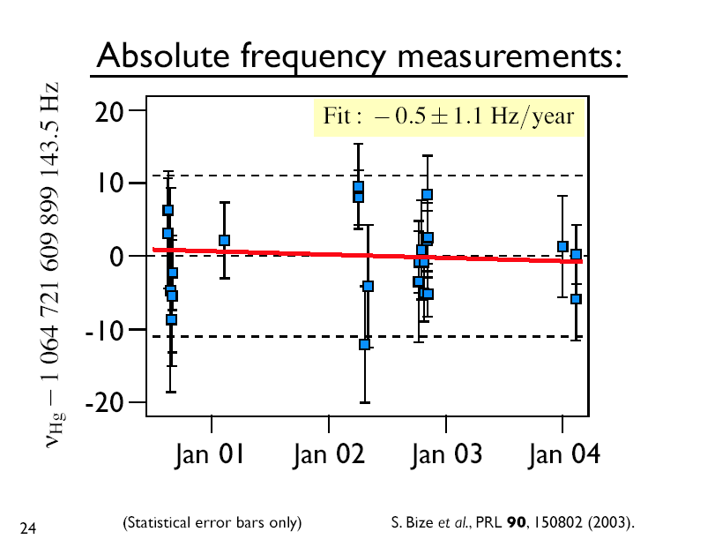

Fig.1 Long-term absolute frequency measurement of the Hg ion-based optical frequency standard.

Research on other optical frequency standards at NIST--

- JILA has a serious effort looking at laser-cooled and trapped Strontium for use as an optical frequency standard.
- The Time and Frequency division is beginning an experiment to study laser- cooled and trapped Ytterbium for use as an optical frequency standard.
- Work on a sympathetically cooled Al⁺ optical standard using a single Be⁺ ion and quantum entanglement techniques is rapidly progressing. Both ions have been loaded and cooled; the optical clock transition is being pursued.

Update on optical frequency combs at NIST—

- During the last year, an international collaboration between BIPM, ECNU (East China Normal University) and NIST looked at the performance that can be achieved in optical frequency synthesis using optical frequency combs based on mode-locked lasers. The results of that study were recently published, and showed that the femtosecond combs should not limit the performance of the next generation of optical frequency standards and clocks. Briefly, the results showed that two femtosecond combs locked to the same optical frequency reference can have:
    - Relative frequency instability about 2x10⁻¹⁷ at 1 second.
    - Optical frequency reproducibility of about 1x10⁻¹⁹.
- A separate study showed that it is possible to narrow the linewidth of all the modes of the optical frequency comb by locking the comb tightly to a narrow linewidth cw reference laser. The linewidth of the optical comb modes relative to the cw laser can be less than 1 Hz, and show spectral coherence across the entire spectrum of the comb that persists for up to ten seconds.

Thesis, Elizabeth Anne Curtis, University of Colorado, 2003.
No collisional shift is observed but uncertainty in the coefficient sets the uncertainty, were we have assumed linear density dependence and a density in atoms/cm³.
Bias is the difference in Stark shift for two levels of the clock transition and the uncertainty comes from lack of knowledge of matrix elements, but should be measurable experimentally in the future.
Uncertainty in the coefficients and geometrical factors can dominate uncertainty.
Present limits are due to phase shifts in AOMs that chop the clock laser beams on and off.
Proportional to linewidth
Part of this is due to atomic recoil.
total is taken as rms sum of individual terms.
Long-Sheng Ma et al., Science, 19 Mar. 2004
A. Bartels et al. Optics Lett., to be published.

