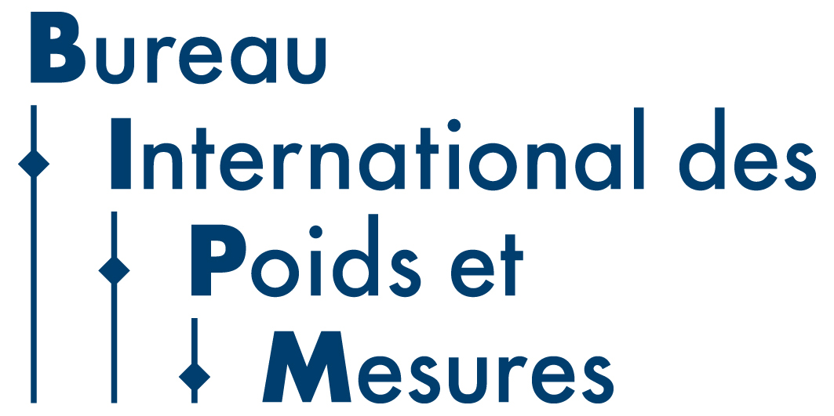


Draft Agenda for the 26th meeting of CCQM – 26-28 April 2021

On-line meeting (All times are UTC +2, Paris time)

Day 1: Monday 26 April 2021

CCQM Plenary Session
Chair: Sang-Ryoul Park

12.00-12.15 1. Opening of the meeting, welcome (S-R. Park)
2. Presentation of list of participants and rules of order for on-line meeting (R. Wielgosz)
3. Appointment of a Rapporteur
4. Approval of the Agenda

12.15-12.35 5. Overview of CCQM activities since the 25th meeting of the CCQM, April 2019 (S-R. Park)
12.35-12.45 Discussion on Agenda Item 5

12.45-13.00 6. Pandemic response case study: CCQM-P199.b, SARS-CoV-2 viral RNA quantification with RT-dPCR (J. Huggett)
13.00-13.05 Questions on Agenda Item 6

13.05-13.45 7. Ensuring reliable measurements for infectious diseases: How will NMI and CCQM activities evolve? Presentations (NRC, LGC, NIM, NMIA, KRISS, NIST) and Discussion

8. CCQM 2021-2030 strategy: [CCQM/21-18]
13.45-13.55 CCQM Vision and Mission Statements and Strategic Aims (S-R. Park)
13.55-14.00 Timetable for CCQM WG Strategies discussion and finalization (R. Wielgosz)

14.00-14.10 9. CIPM Evolving Needs in Metrology Study and impact for CCQM (S-R. Park)
14.10-14.30 Questions on Agenda Items 8 and 9

Day 2: Tuesday 27 April 2021
CCQM Plenary Session
Chair: Sang-Ryoul Park

10. Reports from the CCQM Working groups: 2021-2030 strategy documents
CCQM WG strategy documents have been published and are available for consultation. Pre-recorded presentations on WG strategies will be recorded and should be viewed prior to the meeting date.

12.00-12.05 10.1 CCQM WG 2021-2030 Strategy Elevator Pitch Presentations: OAWG [CCQM/21-06,12]
12.05-12.15 Questions and Discussion

12.15-12.25 10.2 CCQM WG 2021-2030 Strategy Elevator Pitch Presentations: GAWG and IRWG
[CCQM/21-05,10,11,29]
12.25-12.40 Questions and Discussion

12.40-12.55 10.3 CCQM WG 2021-2030 Strategy Elevator Pitch Presentations: IAWG, EAWG, SAWG
[CCQM/21-13,15,16,19,22,27]
12.55-13.10 Questions and Discussion

13.10-13.25 10.4 CCQM WG 2021-2030 Strategy Elevator Pitch Presentations: PAWG, NAWG, CAWG
[CCQM/21-09,14,17,30,31]
13.25-13.40 Questions and Discussion

13.40-13.55 10.5 BIPM Programme on Metrology in Chemistry [CCQM/21-23]
13.55-14.05 Questions and discussion

14.05-14.15 11. Ad hoc CCQM WG on update of KCRV estimation guidance [CCQM/21-08]
14.15-14.30 Questions and discussion

Day 3: Wednesday 28 April 2021

CCQM Plenary Session
Chair: Sang-Ryoul Park

12.00-12.15 12. Overview and status of CCQM Strategy Document 2021-2030 (S-R. Park) [CCQM/21-18]
12.15-12.35 Questions and discussion on CCQM and BIPM future activities and agreement on CCQM Strategy Document 2021-2030 content

12.35-12.50 13. Key Comparison and CMC Quality WG Report [CCQM/21-28]
13.1 Questions on KCDB 2.0 CMC review implementation
12.50-13.00 13.2 Presentation and approval of planned CCQM comparison list

13.00-13.15 14. Report from the JCTLM

13.15-13.30 15. Questions on written reports/recorded presentations from RMOs: AFRIMETS; APMP; COOMET; EURAMET; GULFMET; SIM[CCQM/21-4,24,32,33,34]]

13.30-13.45 16. Questions on written reports/recorded presentations from International Organizations in liaison with the CCQM: International Atomic Energy Agency [IAEA] [CCQM/21-26]; International Federation of Clinical Chemistry and Laboratory Medicine [IFCC] [CCQM/21-25]; European Commission Joint Research Centre [JRC]; International Union of Pure and Applied Chemistry [IUPAC] [CCQM/21-02]; ISO REMCO[CCQM/21-03]; Cooperation on International Traceability in Analytical Chemistry [CITAC] [CCQM/21-07]

13.45-14.10 17. CCQM meetings
17.1 Arrangements for CCQM WG meetings to be held in 2021 & 2022
17.2 Arrangements for next year’s April CCQM meetings
17.3 Proposals for CCQM/BIPM Workshops/ Webinars 2021-2023

14.10-14.30 18. Closing remarks from CCQM President
14.30 Close

