**NOTICE TO USERS**

This document is intended to be used as a template for the generation of reports for CIPM key comparison (KC) studies undertaken within the CCQM IAWG. It can be adapted for other IAWG studies, such as pilot studies (PS); however, the requirements for these reports may not be as stringent. It can also be adapted by the RMOs when generating reports for supplementary comparisons (SC), key comparisons that link to CIPM key comparisons, and pilot studies.

The design of the template is two-fold: 1) black text gives language and content that is recommended, but may be replaced if appropriate to do so; and 2) blue text denotes information that should be supplied by the user.

A few select tables and figures have been given within the template as examples only, and these represent the types of illustrations that should be provided within these reports. It is the study coordinator’s responsibility to generate the needed tables and figures for the particular study at hand. Additional graphics and data summaries should be added as needed.

It is incumbent on the user of this template to ensure that the content of the final report is accurate and reflective of the comparison being reported.

Use for KC Reporting

This template can be used to generate Draft A, Draft B, and Final Reports.

*Draft A:* In general, the Draft A report should contain all technical details and measurement results reported by the participants, but the results should be anonymized until each participant has confirmed that their results have been recorded correctly in the report. Draft A reports may also contain proposed KCRV estimators. Measurement results for a PS that has been run in parallel to a KC can be included in the Draft A report but must be separated into a dedicated PS report at the Draft B stage. Please remember that a Draft A report is confidential amongst the participants until it has been approved by all participants, at which point it becomes Draft B.

*Draft B:* The Draft B report should contain the proposed KCRV values and, as just stated, should not include parallel pilot study data. The Draft B report is not confidential among the participants of the study but can and will be shared by the IAWG chair with the IAWG. Once the Draft B report has been reviewed by the IAWG and approved by the IAWG Chair and the CCQM, it becomes the Final Report, which is the final version that will be provided for the KCDB and will serve as the permanent record for the study.

Use for PS Reporting

This template can be used to generate PS reports, whether standalone or run in parallel to a KC. A PS report should in general be quite similar to a KC report, but shall not contain degrees of equivalence, except in extraordinary circumstances and approved by the IAWG Chair. The drafting and approval processes for PS reports is the same as for KC reports described above, except that approval by the CCQM is not required.

*This page should be deleted from the final report.*

**[Study number (e.g., CCQM-KXXX)]**

[Study title (e.g., Analyte(s) in XXX Matrix: Subtitle)]

**[Key Comparison, Pilot Study]**

**[Month 20XX]**

**Authors:**

Author1, Author2, and Author3, …

Affiliations

1 NMI/DI Full Name

² NMI/DI Full Name

3 NMI/DI Full Name

…

**Coordinators:**

SUMMARY

(to be used as the Metrologia abstract)

Provide a brief description of the relevance of the measurand/study material measurement challenge, with an emphasis on its international importance. Include a brief description of the relevant or typically encountered measurand ranges. Add any other notable statements for why this key comparison was supported. Evidence of successful participation in formal, relevant, international comparisons is usually needed to document calibration and measurement capability (CMC) claims made by national metrology institutes (NMIs) and designated institutes (DIs).

[Number] of National Metrology Institutes and Designated Institutes participated in the key comparison [CCQM-KXXX] [Main Title]. Participants were requested to evaluate the [measurands, probably mass fractions for the IAWG, but could be something else] of [analytes]in [description of materials]. Summarize the methods and techniques employed by the participants. Also include a statement on how the Key Comparison Reference Values (KCRVs) were assigned to the various measurands. For the Final Report, a summary of the KCRVs or SCRVs can be included.

Successful participation in [CCQM-KXXX] demonstrates measurement capabilities in determining [measurands] of [analyte types – can use analyte categories from the IAWG core capability matrix], in [measurands] range from 0.00 [units] to 0.00 [units] in a [description of types matrix – can use matrix challenge categories from the IAWG core capability matrix]. Summarize the performance of the participants.

Table of Contents

INTRODUCTION 6

TIMELINE 7

MEASURANDS 7

STUDY MATERIALS 7

PARTICIPANTS, INSTRUCTIONS AND SAMPLE DISTRIBUTION 8

RESULTS 10

KEY COMPARISON REFERENCE VALUE (KCRV) ESTIMATIONS 13

DEGREES OF EQUIVALENCE 16

USE OF [CCQM-KXXX] IN SUPPORT OF CALIBRATION AND MEASUREMENT CAPABILITY (CMC) CLAIMS 18

CONCLUSIONS 18

ACKNOWLEDGEMENTS 18

REFERENCES 18

APPENDIX A: Call for Participation and Technical Protocol 19

APPENDIX B: Registration Form 20

APPENDIX C: Reporting Form 21

APPENDIX D: Summary of Participants’ Analytical Information 22

APPENDIX E: Summary of Participants’ Uncertainty Estimation Approaches 23

Example LIST OF TABLES

Table X: Timeline for [CCQM-KXXX] 1

Table X. Results of the homogeneity assessment for [measurand in matrix] 1

Table X: Institutions receiving [CCQM-KXXX] sample materials 1

Table X: Certified Reference Materials used 1

Table X: Metrological traceability of participants’ results 1

Table X: Reported results for moisture (if applicable), Measurand 1 and Measurand 2 1

Table X: Results results by participants, Measurand 1 and Measurand 2 1

Table X: Key Comparison Reference Values for Measurand 1 and Measurand 2 1

Table X: Degrees of Equivalence for Measurand 1 and Measurand 2 1

Example LIST OF FIGURES

Figure X: Dot-and-bar display of reported results for Measurand 1 and Measurand 2 1

Figure X: KCRV value for Measurand 1 and Measurand 2 10

Figure X: Degrees of Equivalence for Measurand 1 and Measurand 2 12

ACRONYMS

# INTRODUCTION

Include a paragraph that describes why the IAWG has decided to perform this study. Examples of things to include are the international importance of the study, how it will underpin core competencies, and any reference to regulatory drivers and relevance. [A list of relevant competencies for this study] [measurement level and complex matrix type] are important challenges for reference material producers and providers of other measurement services, such as proficiency testing schemes. Evidence of successful participation in formal, relevant international comparisons is needed to document calibration and measurement capability claims (CMCs) made by national metrology institutes (NMIs) and designated institutes (DIs).

In [Month 20XX], the Consultative Committee for Amount of Substance: Metrology in Chemistry and Biology (CCQM) approved the Key Comparison (KC) [CCQM-KXXX] [Main Title] [[1]]. [CCQM-KXXX] was designed to assess participants’ capabilities for [a description of the measurement challenge]. Describe how the KC fits into the IAWG strategy, the 5-year plan and the Core Capability approach. Describe why the analyte/matrix was selected. Describe any previous comparisons that underpin similar competencies, or which complement this KC.

Include a paragraph that describes the analytical challenges and competencies that this study addresses. Include a description of the methods and how they can be used to represent the way they deliver measurement services to their customers. If a parallel pilot study was also run, mention it here for information; but this should be the only mention of it in this key comparison report, because it will have its own report.

The following sections of this report document the timeline of [CCQM-KXXX], the measurands, study material, participants, results, and the measurement capability claims that participation in [CCQM-KXXX] can support. The Appendices reproduce the official communication materials and summaries of information about the results provided by the participants.

# TIMELINE

Example Table X lists the timeline for [CCQM-KXXX].

Example Table X: Timeline for [CCQM-KXXX] [Modify the table as necessary to record all of the important milestones for this study.]

|  |  |
| --- | --- |
| Date | Action |
| Month 20XX | Proposed to CCQM |
| Month 20XX | Draft protocol presented to IAWG |
| Month 20XX | IAWG authorized [CCQM-KXXX] |
| Month 20XX | Call for participation to IAWG members |
| Month 20XX to Month 20XX | Study samples shipped to participants. The range in shipping times reflects delays from shipping and customs. |
| Month 20XX | Results due to coordinating laboratory |
| Month 20XX | Draft A report distributed to participants |
| Month 20XX | Draft B report distributed to IAWG |
| TBD | Final report approved by IAWG |

# MEASURANDS

Include a paragraph describing the analyte(s) and measurand(s) (on a dry mass basis/as received), in what particular matrix (e.g., freshwater,sediment, …) and with stated units. Add any other points here that are important with regard to the selection of measurands.

# STUDY MATERIALS

Include background on the study materials, including source, processing and grinding, particle size, etc. Also, include a description on how the samples are packed and the unit size.

Each participant received [number and type of materials]: [details on samples and materials as necessary]. The recommended minimum sample amount for analysis was at least 00.0 [units]. Measurement results were to be reported on a [dry-mass or as received basis].

**Dry Mass Determination (where relevant)**

Add relevant description of methods that were to be used for determination of moisture/dry mass, with details on subsampling, number of subsamples, minimal sample size, etc. If all participants were required to follow the method outlined in the protocol, state this fact.

**Homogeneity Assessment of Study Material**

Use this section to describe how the homogeneity (or heterogeneity) was determined for the material. Include a description of the laboratory analysis method that was used to evaluate any significant differences between-packet or within-packet. Also include a description of any statistical procedures applied, such as the typical one-way ANOVA. Include any summary of the coefficient(s) of variation and any expected measurement standard uncertainties.

Example Table X. Results of the homogeneity assessment for [details on measurand/matrix].

|  |  |  |
| --- | --- | --- |
| ANOVA Estimate | Measurand 1 | Measurand 2 |
| Within-packet, CVwth: | 0.0 % | 0.0 % |
| Between-packet, CVbtw: | 0.0 % | 0.0 % |
| Total analytical variability, CV: | 0.0 % | 0.0 % |
| Probability of falsely rejecting the hypothesis   that all samples have the same measurand value: | 00 % | 00 % |

**Stability Assessment of Study Material**

Provide a detailed description of formal stability studies for the material(s), which should include a discussion on long term and transport stability. The latter may not be always necessary, but the reason for omitting it should be justified. Details on any freeze-thaw stability evaluations can also be useful, especially for any biological materials and particle suspensions.

Graphs of stability data (short-term and long-term, if possible) for individual measurand/matrix combinations should be given, because these can be very useful for communicating stability results.

# 

# PARTICIPANTS, INSTRUCTIONS AND SAMPLE DISTRIBUTION

The call for participation, reproduced along with the study protocol in Appendix A, was distributed in [Month 20XX]. Table X lists the institutions that registered for [CCQM-KXXX] [Please ensure there are no email addresses or any other specific contact information in the table, especially for a key comparison Final Report, which will become publicly accessible when published in the KCDB.]

Example Table X: Institutions Registered for [CCQM-KXXX]

|  |  |  |  |
| --- | --- | --- | --- |
| **NMI or DI** | **Code** | **Country** | **Contact** |
| NMI 1 Full Name | NMI 1 | Country1 | First Name Last Name |
| NMI 2 Full Name | NMI 2 | Country2 | First Name Last Name |
| NMI 3 Full Name | NMI 3 | Country3 | First Name Last Name |
| NMI 4 Full Name | NMI 4 | Country4 | First Name Last Name |
| NMI 5 Full Name | NMI 5 | Country5 | First Name Last Name |

Describe the sample distribution and add further information as required on any notable shipping delays, issues, etc. If temperatures were monitored during transport, describe results. Outline any participants who did not receive samples.

Describe if any participants withdrew, at what stage, and (if the participant approves) the reason for withdrawal.

# RESULTS

Participants were requested to report [describe here the reporting requirements for participation in the comparison, including number of subsamples, single final value for each measurand, uncertainty, degrees of freedom, etc., on a dry mass basis or as received].

In addition to the quantitative results, participants were instructed to describe their analytical methods and approach to uncertainty estimation. Appendix C reproduces the report form.

[CCQM-KXXX] results were received from [00] of the [00] institutions that received samples. [If any participants were unable to return results, describe that here, including the reasons.]

## 

**Methods Used by Participants**

Describe methodologies employed by participants and include a table summarizing main attributes. Outline any obvious trends (e.g., most participants employed …).

Full details of each participant’s analytical method are provided in Appendix D. Each participant’s approach to uncertainty estimation is described in Appendix E.

Table X summarizes the measurement methods used by the participating NMIs/DIs for CCQM-**KXXX**

Example Table X: summary of measurement methods used

|  |  |  |  |  |  |
| --- | --- | --- | --- | --- | --- |
| Participating NMI/DI | Measurand | Sample preparation method | Calibration method | Analytical instrument | Reference material used for calibration (traceability) |
|  |  |  |  |  |  |
|  |  |  |  |  |  |
|  |  |  |  |  |  |
|  |  |  |  |  |  |

**Calibration Materials Used by Participants**

Participants **were allowed to** establish the metrological traceability of their results to the SI using a direct realization via a primary method, certified reference materials (CRMs) from an NMI/DI having the required CMC claims, or by preparing their own calibration standards using commercially available high purity materials for which they determined the purity themselves.

Describe how SI traceability was established by the participants. If any participants established traceability by preparing their own calibration standards, describe how that was done, especially how the purity of the calibration materials was evaluated.

Discuss any issues with the traceability of the calibrants or with the evidence to support the technique used to carry out an in-house assessment. Clarify if any results were not included in the KCRV calculation as a result of insufficient metrological traceability.

**Participant Results for Moisture (if applicable)**

Describe how the participants determined the moisture correction, especially if they did not follow the directions in the comparison’s technical protocol. A table of the approaches used might be helpful.

The moisture values measured by the participants are [provided in Table X or graphed in Figure X]. State any important disagreements among the set of moisture results, or any trends (e.g., specific approaches tended to yield higher values).

Add Table X or Figure X here, as appropriate.

**Participant Results for [Measurand 1, Measurand 2, …]**

Use this section to describe any trends in the results, or any general observations for the reported datasets.

The results for [CCQM-KXXX] for the determination of [measurand 1 and measurand 2] are detailed in Table X and presented graphically in Figure X. If applicable, add this statement: The results for QC samples are presented in Table X [and note if any participants did not use a QC sample].

Table x. Reported results for [Measurand X]

|  |  |  |  |  |
| --- | --- | --- | --- | --- |
| Participating NMI/DI | Reported [measurand] (Units) | Reported standard uncertainty (Units) | Coverage factor, k | Expanded uncertainty (Units) |
|  |  |  |  |  |
|  |  |  |  |  |
|  |  |  |  |  |

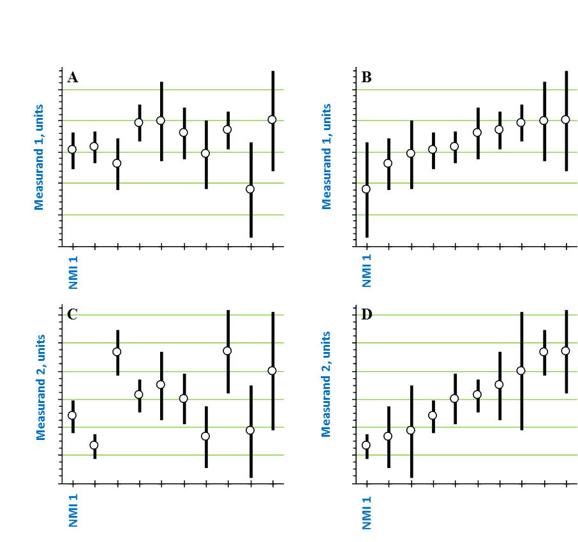

Example Figure X: Reported results for [measurand]. Uncertainty bars represent the reported expanded uncertainty values.

Table x. Reported results on matrix CRMs used for QC

|  |  |  |  |  |  |  |  |
| --- | --- | --- | --- | --- | --- | --- | --- |
| Participating NMI/DI | CRM | Measurand | Certified value (Units) | Expanded uncertainty of the certified value (Units) | Found value (Units) | Found standard uncertainty (Units) | Expanded uncertainty (Units) |
|  |  |  |  |  |  |  |  |
|  |  |  |  |  |  |  |  |
|  |  |  |  |  |  |  |  |

**Discussion of Results**

Describe any issues and outline any further work carried out by participants following the original presentation of the results. Often some participants will have carried out specific further investigations. Include revised data where relevant.

Outline any issues raised with respect to methods used.

Also outline any issues in relation to any uncertainties that may be over or underestimated. In some cases, a specific section on uncertainty may be justified.

# KEY COMPARISON REFERENCE VALUE (KCRV) ESTIMATIONS

Usually, it will be best to organize this section into subsections, one for each measurand, but other approaches can be used if it makes more sense to do so. The goal is clear communication of the results, no matter how it is arranged. The choice of appropriate estimators should be based on the NIST Decision Tree, as agreed by the IAWG, unless there is a good reason to use another approach.

As per the agreement made by the IAWG, the NIST Decision Tree (NDT, (Version x.x.x)) was used to calculate the KCRVs and the degrees of equivalence (DoEs) of participants. The NDT requires the identification of participants, reported results, uncertainties, and degrees of freedom (DoFs) as input. When a participant did not report the DoF value, it has been estimated based on the reported coverage factor. Following a series of hypothesis tests related to homogeneity, symmetry, and normality (Gaussian shape) of the set of data, the NDT recommends the best statistical model for calculating the KCRV and DoE. The recommendation of the NDT has been followed, unless otherwise noted.

Note that you can include the actual pdf reports from the NDT as an additional Annex, if you prefer. However, it is not necessary to do this, because the tables and figures in the following subsections will include the important information.

In the following example subsection, use of the NDT is assumed:

Measurand 1

Clearly articulate any data that are being excluded from the KCRV calculation and why, along with any other observations you believe are relevant.

Note that the table will be slightly different, depending on the estimation approach selected.

Table X provides the output of the NDT, including the KCRV results, and Figure X plots KCRV and its uncertainty along with the dataset:

If the Adaptive Weighted Average is used:

Table X: NDT decision for Measurand 1

|  |  |
| --- | --- |
| **Decision Tree Hypothesis test results:** Measurand 1 | **Decision Tree recommends [procedure recommended by NDT]** |
| Cochran’s test for Homogeneity:  p-value:  Q =  tau est. =  tau/median(x) =  tau/median(u) =  Shapiro-Wilk test for Normality: p =  Miao-Gel-Gastwirth test of Symmetry: p =  Assume Homogeneity? Yes  Assume Normality? Yes  Assume Symmetry? Yes | Selected Procedure: Adaptive Weighted Average  Consensus estimate:  Standard uncertainty:  Standard uncertainty (using parametric bootstrap):  95% coverage interval:  95% coverage interval (using parametric bootstrap):  Dark uncertainty (tau): |

If the Weighted Median is used:

Table X: NDT decision for Measurand 1

|  |  |
| --- | --- |
| **Decision Tree Hypothesis test results:** Measurand 1 | **Decision Tree recommends [procedure recommended by NDT]** |
| Cochran’s test for Homogeneity:  p-value:  Q =  tau est. =  tau/median(x) =  tau/median(u) =  Shapiro-Wilk test for Normality: p =  Miao-Gel-Gastwirth test of Symmetry: p =  Assume Homogeneity? Yes  Assume Normality? Yes  Assume Symmetry? Yes | Selected Procedure: Weighted Median  Consensus estimate:  Standard uncertainty:  95% coverage interval: |

If any of the three Hierarchical procedures are used:

Table X: NDT decision for Measurand 1

|  |  |
| --- | --- |
| **Decision Tree Hypothesis test results:** Measurand 1 | **Decision Tree recommends [procedure recommended by NDT]** |
| Cochran’s test for Homogeneity:  p-value:  Q =  tau est. =  tau/median(x) =  tau/median(u) =  Shapiro-Wilk test for Normality: p =  Miao-Gel-Gastwirth test of Symmetry: p =  Assume Homogeneity? Yes  Assume Normality? Yes  Assume Symmetry? Yes | Selected Procedure: Hierarchical [Gauss-Gauss or Laplace-Gauss or Skew Student-Gauss]  Consensus estimate:  Standard uncertainty:  95% coverage interval:  Dark uncertainty (tau):  Tau posterior 0.025 and 0.975 quantiles: |

Copy and paste the following figure from the NDT report, and include a figure caption like that shown below it. Notice that the NDT software does NOT print units for the y-axis; you will need to supply those yourself in a text box.

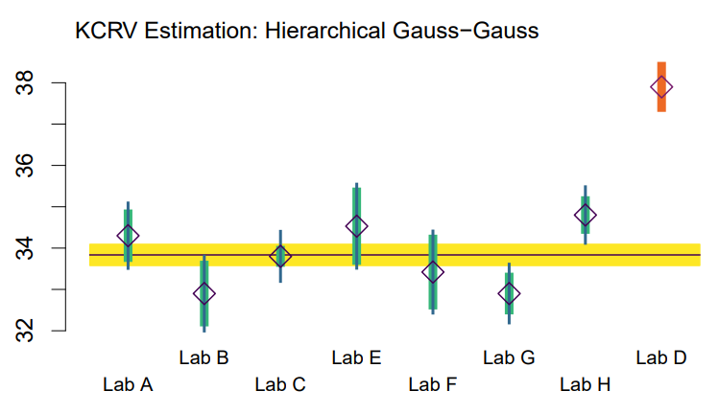

Measurand 1

Units

Figure X. Participant results for Measurand 1 compared to the consensus value. The KCRV is depicted as the black horizontal line, and its standard uncertainty is the gold bar. For each participant, the thick green vertical bar represents the reported standard uncertainty, and the thin black extensions represent the contribution of dark uncertainty. The orange points to the right were excluded from the dataset for the KCRV estimation.

Measurand 2

Repeat subsection entries for the second measurand, and so forth …

# DEGREES OF EQUIVALENCE

The degrees of equivalence were evaluated using the NIST Decision Tree and according to the “IAWG Guidance on Using NIST Decision Tree for Comparison Reporting” found at chrome-extension://efaidnbmnnnibpcajpcglclefindmkaj/https://www.bipm.org/documents/20126/189731284/IAWG+Guidance+on+Using+NIST+Decision+Tree+for+Comparison+Reporting/ad9e39d8-c20a-4591-60bc-651d28abad34. The DoE value for a given measurand and for the *i*th participant, *Di*, is the reported measurement value, *xi*, minus the KCRV. They are listed in Tables X-X and graphically shown in Figures Y-Y. For the NDT procedures used to estimate each of the KCRVs in this comparison, the expanded uncertainty of *Di*, *U*(*Di*), is half the shortest interval centered on *Di* that is believed to encompass the true value with 95 % probability, where the endpoints of the interval are derived directly from a large sample drawn from the corresponding probability distribution. Therefore, the error bars in the plots represent the expanded uncertainties of *Di* at 95 % confidence level, *U*(*Di*). In these figures, the horizontal line denotes perfect agreement with the KCRV, the black dot represents the *Di* value, and the uncertainty bars represent *U*(*Di*).

Example Table X. Degrees of equivalence for Measurand 1

|  |  |  |  |  |  |
| --- | --- | --- | --- | --- | --- |
| NMI/DI | Reported mass fraction, *xi* (mg/kg) | Standard uncertainty,  *ui* (mg/kg) | Difference from KCRV, *Di* (mg/kg) | Expanded uncertainty of the difference,  *U*(*Di*) (mg/kg) | *Di*/*U*(*Di*) |
| A* | 0.939 | 0.088# | -0.406 | 0.213 | -1.90 |
| B | 1.054 | 0.097# | -0.291 | 0.229 | -1.27 |
| C | 1.322 | 0.020 | -0.023 | 0.072 | -0.32 |
| D | 1.352 | 0.015 | 0.007 | 0.070 | 0.10 |
| E | 1.3640 | 0.0062 | 0.0188 | 0.0625 | 0.30 |
| F | 1.374 | 0.018 | 0.029 | 0.070 | 0.41 |
| G | 1.381 | 0.020 | 0.036 | 0.072 | 0.50 |
| H | 1.385 | 0.033 | 0.040 | 0.089 | 0.45 |
| I | 1.490 | 0.060 | 0.145 | 0.156 | 0.93 |

The symbol * indicates reported result excluded from the KCRV calculation.

The values with symbol # are the participant’s reported uncertainty and the dark uncertainty, *t*, summed in quadrature.

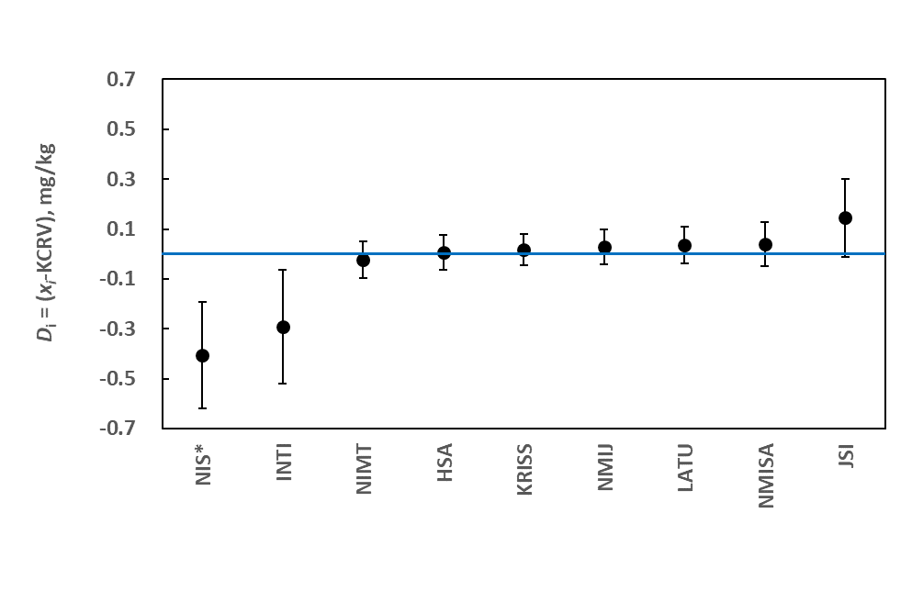

Figure X. Degrees of equivalence for Measurand 1. Dots represent *Di*, and error bars represent their expanded uncertainties, *U*(*Di*) at approximately 95 % confidence. The blue horizontal line denotes perfect agreement with the KCRV. The symbol * indicates reported result excluded from the KCRV calculation.

# 

# USE OF [CCQM-KXXX] IN SUPPORT OF CALIBRATION AND MEASUREMENT CAPABILITY (CMC) CLAIMS

**How Far the Light Shines**

Successful participation in [CCQM-KXXX] demonstrates the following measurement capabilities in determining measurands of [analytes], in measurand range from 0.00 [units] to 0.00 [units] in a [description of types matrix]. Expand this statement as determined in discussions within the IAWG …

Use this section to flag the level of agreement with the KCRVs.

**Core Capability Table**

Insert here the CC table showing the measurement space covered by the study.

# CONCLUSIONS

The conclusions are to be determined after agreement reached on which of the candidate KCRV models to use.

# ACKNOWLEDGEMENTS

The study coordinators thank the participating laboratories for providing the requested information used in this study.

# 

# REFERENCES

# APPENDIX A: Call for Participation and Technical Protocol

Use this section to provide text copies of the Call for Participation and Technical Protocol. Please remove any lists of email addresses or any other specific contact information of the participants, because this Final Report will become publicly accessible.

# APPENDIX B: Registration Form

Use this section to provide text copies of any registration forms that were distributed to either the IAWG at large, or to individual participants of the study.

# APPENDIX C: Reporting Form

Use this section to provide text copies of any reporting forms that were distributed to the participants of the study.

It is strongly recommended that all reporting forms be created in a document format, not a spreadsheet format, and that all data should be entered as individual values (or as text). If a spreadsheet must be used, all data should be entered as individual values and NOT to include formulas.

# APPENDIX D: Summary of Participants’ Analytical Information

The following Tables summarize the detailed information about the analytical procedures each participant provided in their “Analytical Information” worksheets. The presentation of the information in many entries has been consolidated and standardized.

The participant’s measurement uncertainty statements are provided verbatim in Appendix E.

Use this section to also include any relevant institutional disclaimers.

# APPENDIX E: Summary of Participants’ Uncertainty Estimation Approaches

The following are text excerpts and/or pictures of the uncertainty-related information provided by the participants in the reporting form. Information is grouped by participant and presented in alphabetized acronym order.

Uncertainty Information from NMI 1

Use this section to document the uncertainty information provided from the individual NMIs. It should at least include the following information: 1) measurement or observation equation, 2) definition of parameters and their associated values, 3) uncertainty budget for the various terms, and for all the measurands in the study, and 4) a summary of the uncertainties associated with the measurement or observation equation (step 1).

The layout for this information will be dictated by the study protocol and its associated reporting form(s).

1.