30 November 2021
2021 CCPR WG-SP
To: Maria Nadal, NIST, Chairperson for CCPR WG-SP
From: John Lehman, NIST
Subject: TG 14: Discussion Forum on Radiometry to Support Gravitational Wave Detection
Objectives of the CCPR-WG-SP Task Group 14 are:
- to discuss measurement issues and report on progress of the work performed in NMIs
- to identify new measurements needs of the community undertaking detection of gravitational waves
- to define priorities in terms of research activities
- to facilitate coordinated research work between country specific NMIs and the respective gravitational wave observatories.

The activities of this TG most recently are comparisons between NIST and PTB and discussions with LIGO about future calibration campaigns. This is also driven by the desire from gravitational wave observatories for lower uncertainty and calibration of the so-called “P-cal” transfer standards employed by multiple observatories. See for example, Y. Inoue, et al. Phys. Rev. D 98 022005 (2018). “[…] the Pcal still [presents] challenges in finding the absolute calibration because of the uncertainty in the laser power standards published by different national metrology institutes […].”
The most recent outcome from this working group is embodied in The PTB/NIST comparison paper: “A bilateral comparison of NIST and PTB laser power standards for scale realization confidence by gravitational wave observatories,” Matthew Spidell et al., 2021 Metrologia 58 055011.
The results are summarized by the following (a “hop” is hundredths of percent in LIGO lingo):
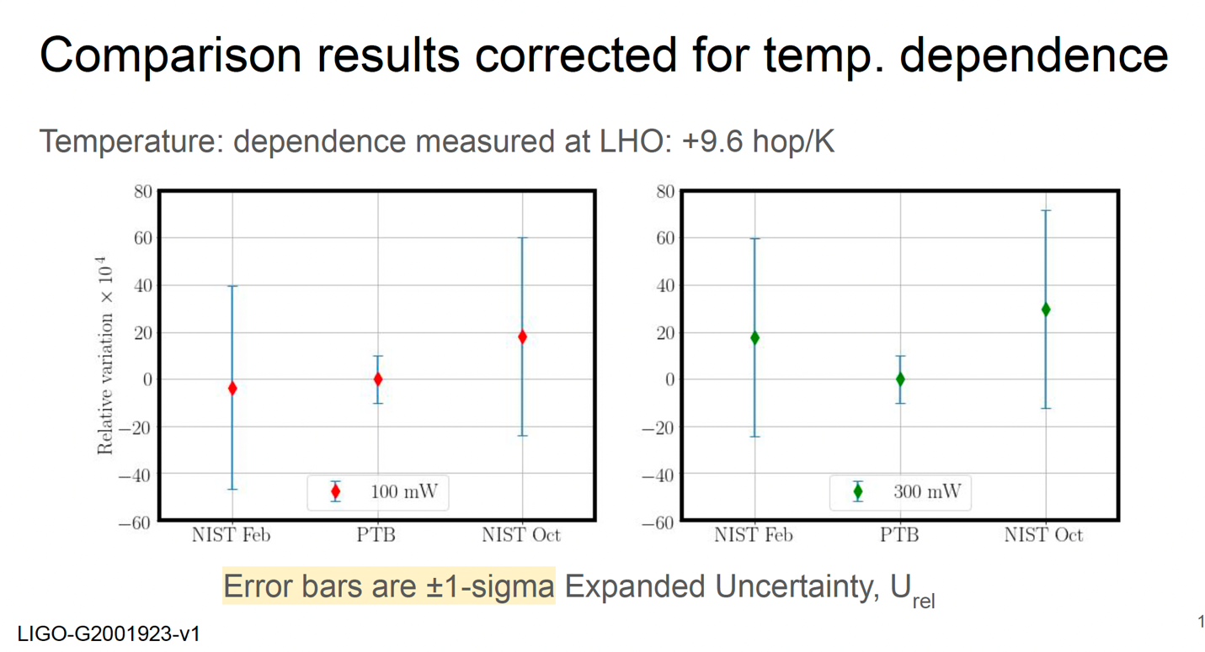
Following further discussions with Dr. Richard Savage of LIGO, the following calibration scheme was proposed. This might be expanded in time to include other NMIs and observatories, but this alone is very ambitious in an annual cycle.
